Interaction Plots©

For each data set, make an “interaction plot” with level of A on the abscissa, mean score on ordinate, and one line for each simple main effect of A (at each level of B). Then make a second plot with B on abscissa and one line for each simple main effect of B. If there is an interaction, write “monotonic” or “nonmonotonic” above each plot. If there is a main effect of A write “main effect of A” below the first plot. If there is a main effect of B, write “main effect of B” below the second plot. The cell entries are means. Assume that you have data for the entire population – in other words, any difference in means is “significant.” I used Microsoft Graph to make the graphs within Word – just click Insert Object, select Microsoft Graph Chart, replace the sample data with your data, right click the chart area and click chart type, choose a line chart, and right click other components you wish to format differently.

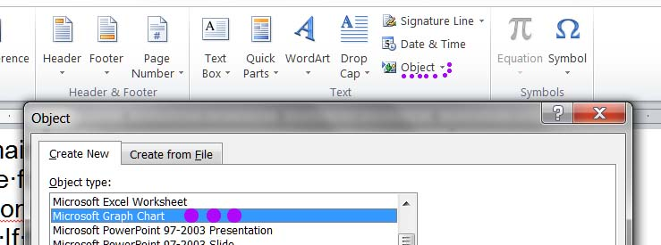

Of course, since you have this file available to you in electronic format, you could just copy and paste my example charts below and then edit them, replacing my data with your data. Double-click the chart to enter editing mode, and then right click and select Datasheet to display the data, which you can edit.

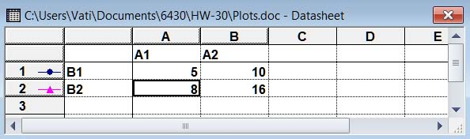

 |  | A
Example |  | 1 | 2 | Marginal mean  In this example, the cell means are blue and the marginal means are green. We assume n is constant across cells, so each marginal mean is the mean of the cell means that contribute to it. There are two levels of Factor A (1 and 2) and two levels of Factor B (1 and 2).
B | 1 | 5 | 10 | 7.5
 | 2 | 8 | 16 | 12.0
Marginal Mean |  | 6.5 | 13

monotonic interaction monotonic interaction

main effect of A main effect of B

You make plots for each of the following 11 data sets

 |  | A |  |  |  |  | A |  |  |  |  | A
#1 |  | 1 | 2 |  | #2 |  | 1 | 2 |  | #3 |  | 1 | 2
B | 1 | 10 | 10 |  | B | 1 | 10 | 20 |  | B | 1 | 10 | 20
 | 2 | 10 | 10 |  |  | 2 | 10 | 20 |  |  | 2 | 30 | 40

 |  | A |  |  |  |  | A |  |  |  |  | A
#4 |  | 1 | 2 |  | #5 |  | 1 | 2 |  | #6 |  | 1 | 2
B | 1 | 10 | 20 |  | B | 1 | 20 | 30 |  | B | 1 | 20 | 40
 | 2 | 30 | 60 |  |  | 2 | 10 | 60 |  |  | 2 | 10 | 50

 |  | A |  |  |  |  | A |  |  |  |  | A
#7 |  | 1 | 2 |  | #8 |  | 1 | 2 |  | #9 |  | 1 | 2
B | 1 | 10 | 50 |  | B | 1 | 20 | 40 |  | B | 1 | 30 | 10
 | 2 | 30 | 30 |  |  | 2 | 40 | 20 |  |  | 2 | 50 | 70

 |  | A |  |  |  |  |  | A
#10 |  | 1 | 2 | 3 |  | #11 |  | 1 | 2 | 3
B | 1 | 10 | 20 | 30 |  | B | 1 | 10 | 30 | 20
 | 2 | 20 | 30 | 70 |  |  | 2 | 30 | 50 | 40

# 12. Three independent variables (A, B, & C) - make an interaction plot with A on abscissa showing the “simple interaction” between A and B using only those data where C = 1. Make a second interaction plot between A and B using only those data where C = 2. Answer these questions:

- Is there a main effect of A if you ignore (collapse across) B and C? (Hint: compare the mean of all the scores at level 1 of A to the mean of all the scores at level 2 of A.)
- Is there a main effect of B if you ignore (collapse across) A and C?
- Is there a main effect of C if you ignore (collapse across) A and B?
- There is a triple interaction. Describe it and explain how you know there is a triple interaction.

C=1 |  |  |  |  | C=2
 |  | A |  |  |  |  | A
 |  | 1 | 2 |  |  |  | 1 | 2
B | 1 | 10 | 20 |  | B | 1 | 10 | 30
 | 2 | 30 | 40 |  |  | 2 | 40 | 40

Copyright 2020, Karl L. Wuensch. All rights reserved.

© Copyright 2020, Karl L. Wuensch. All rights reserved.

