Interaction Significant, Simple Main Effects Not Significant

A sports psychologist at a French university, wrote me for advice about a binary logistic regression. The outcome variable was whether or not the subject had disturbed eating attitudes, and the predictor variables were gender (female, male) and status (athlete or not athlete). Since all variables are dichotomous, a logit analysis would also be an appropriate way to analyze his data.
The analysis showed that there was a significant interaction between gender and status. However, test of the simple effects of status at levels of gender both fell short of significance: Using Pearson χ², p = .059 with the girls and .17 with the boys. This is understandably confusing, and he asked me to advise him regarding how to interpret the significant interaction.
The significant interaction tells us that the odds ratio for the girls (.304/.190 = 1.6) is significant greater than the odds ratio for the boys (.191/.281) = 0.68). The tests of simple effects tells us that neither odds ratio is significantly different from 1. The magnitude of the interaction (1.6 – 0.68 = 0.92) is considerably greater than the magnitude of either simple main effect (1.6 - 1 = 0.6 and .68 - 1 = -0.32), so it is not really surprising that the simple main effects fell just short of significance when the interaction was significant.
I suggested that the results be summarized something like this: The effect of athletic status was significantly different for boys than for girls, with the risk of disordered eating attitudes being greater for athletes among the girls but lesser for athletes among the boys.
One useful way to illustrate an interaction like this is with a plot like that below:
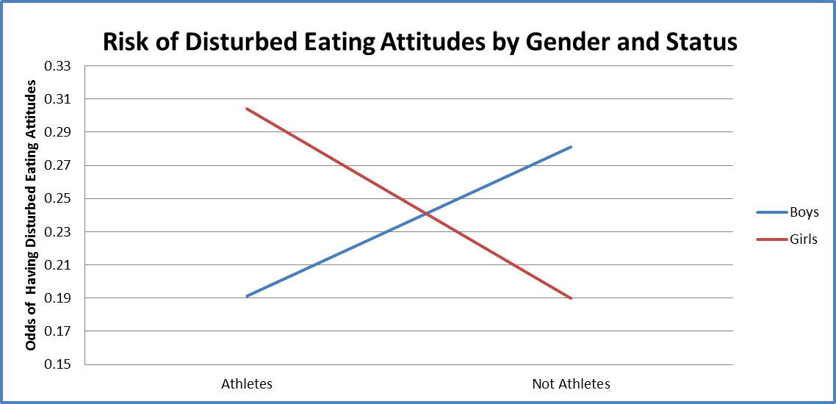

 | Boys | Girls
Athletes | 0.191 | 0.304
Not Athletes | 0.281 | 0.19
I created this plot in Excel 2010 by entering the odds into a 2 x 2 table like this and then requesting a line plot.

Then I exported the worksheet to an htm file and copied the chart (image001.png) from the “_files” folder produced by Excel and associated with the htm file.
Exactly the same thing can happen in a factorial ANOVA. Suppose that the vertical axis represents means on the outcome variable. It is possible for the interaction to be significant but both simple main effects fall short of significance. One way to think of this is that the two lines in the plot have significantly different slopes (one positive, one negative) but neither of them have a slope that is significantly different from zero.

Karl L. Wuensch, January, 2011.

Return to Wuensch’s Stat Help Page

