East Carolina University
Department of Psychology

Interaction Plots Prepared with Excel

You want to prepare an interaction plot that looks better than the crude one produced by PROC PLOT in SAS. You don’t own any fancy plotting software, but you do have Microsoft Excel. Here is what you can do. First, here is the table of means you wish to plot:

Table 1: Means and Standard Deviations
Species of Amanda | Temperature (Celsius) | Mean Activity
carolinis | 5 | 31.80
carolinis | 10 | 54.20
carolinis | 15 | 72.60
carolinis | 20 | 72.40
carolinis | 25 | 40.20
pennsylvanicus | 5 | 76.80
pennsylvanicus | 10 | 59.20
pennsylvanicus | 15 | 67.60
pennsylvanicus | 20 | 92.80
pennsylvanicus | 25 | 50.00
tropicalis | 5 | 63.00
tropicalis | 10 | 71.20
tropicalis | 15 | 83.20
tropicalis | 20 | 82.60
tropicalis | 25 | 90.80

Enter the means into Excel, like this:
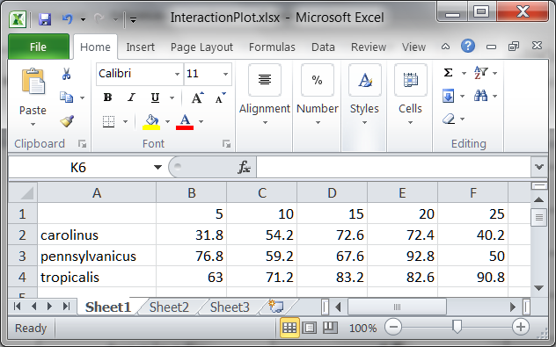

Insert, Charts, Line

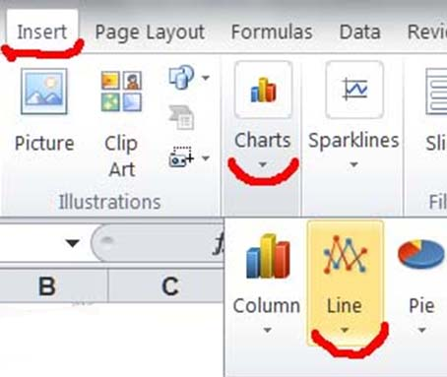

Select “Line with markers.”
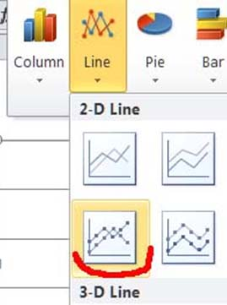

The plot appears:

Tweak the horizontal axis.
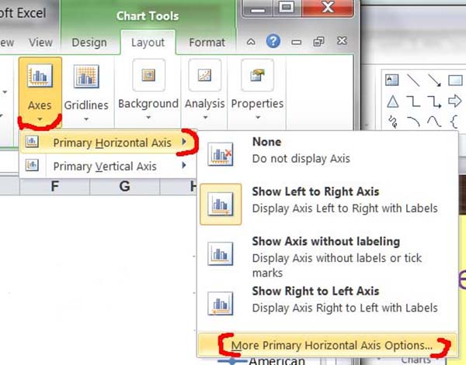

Start at 25 instead of zero.
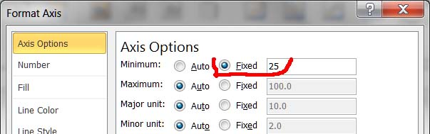

Add Axis Titles

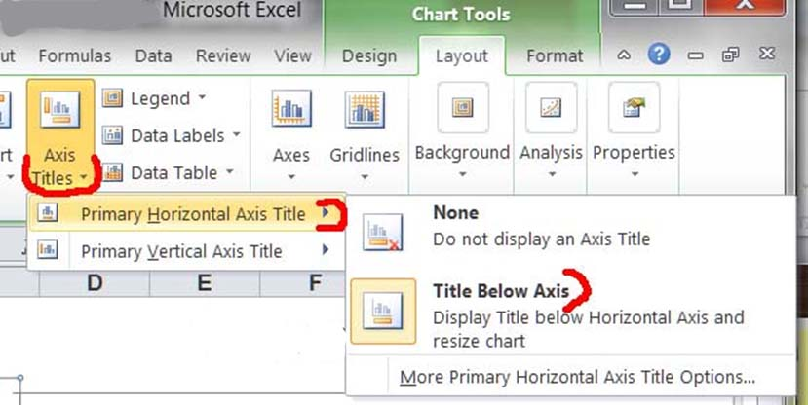

Then do the same for the vertical axis.
Enter a chart title.
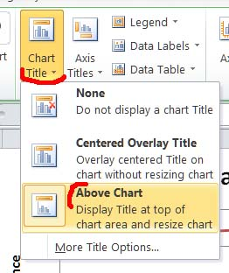

- Download the Excel file used here
- Visit Wuensch’s Stat Help Page
Karl L. Wuensch, 28. January, 2011

