Tab Delimited Data: Importing into SAS

From the File drop-down menu, select Import Data. From the Select Import Type window, select Tab Delimited File (*.txt).
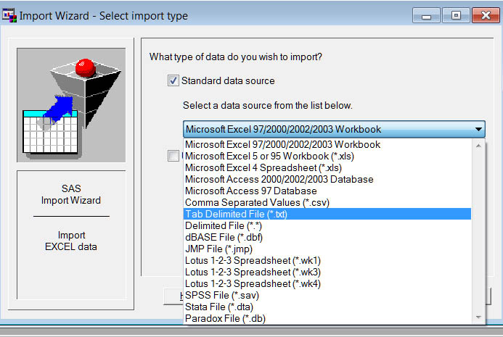

Browse to the location of the source file. In this case it is a tab-delimited text file copied and pasted from http://lib.stat.cmu.edu/DASL/Datafiles/laborlawdat.html .
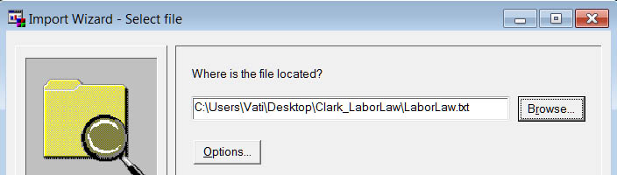
Provide a Member name, pretty much anything you wish.
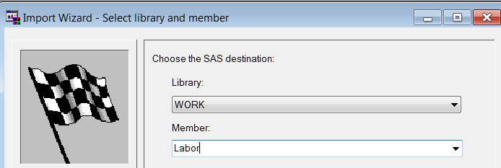

If desired, ask SAS to create a file with the syntax necessary to import these data without needing to go through the wizard again.
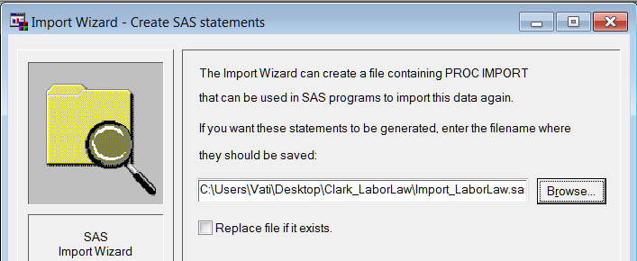

SASLOG
NOTE: Copyright (c) 2002-2008 by SAS Institute Inc., Cary, NC, USA.
NOTE: SAS (r) Proprietary Software 9.2 (TS1M0)
Licensed to EAST CAROLINA UNIVERSITY - ADMIN, Site 0070022653.
NOTE: This session is executing on the W32_VSHOME platform.

NOTE: SAS initialization used:
real time 7.13 seconds
cpu time 0.79 seconds

ERROR: Connect: External table is not in the expected format.
ERROR: Error in the LIBNAME statement.
1 /**********************************************************************
2 * PRODUCT: SAS
3 * VERSION: 9.2
4 * CREATOR: External File Interface
5 * DATE: 05SEP11
6 * DESC: Generated SAS Datastep Code
7 * TEMPLATE SOURCE: (None Specified.)
8 ***********************************************************************/
9 data WORK.Labor ;
10 %let _EFIERR_ = 0; /* set the ERROR detection macro variable */
11 infile 'C:\Users\Vati\Desktop\Clark_LaborLaw\LaborLaw.txt' delimiter='09'x MISSOVER DSD
11 ! lrecl=32767 firstobs=2 ;
12 informat STATE $2. ;
13 informat DENS best32. ;
14 informat COMP best32. ;
15 informat RTW best32. ;
16 informat PVT best32. ;
17 format STATE $2. ;
18 format DENS best12. ;
19 format COMP best12. ;
20 format RTW best12. ;
21 format PVT best12. ;
22 input
23 STATE $
24 DENS
25 COMP
26 RTW
27 PVT
28 ;
29 if _ERROR_ then call symputx('_EFIERR_',1); /* set ERROR detection macro variable */
30 run;

NOTE: The infile 'C:\Users\Vati\Desktop\Clark_LaborLaw\LaborLaw.txt' is:
Filename=C:\Users\Vati\Desktop\Clark_LaborLaw\LaborLaw.txt,
RECFM=V,LRECL=32767,File Size (bytes)=912,
Last Modified=05 September 2011 12:10:41 o'c,
Create Time=05 September 2011 12:10:27 o'c

NOTE: 50 records were read from the infile 'C:\Users\Vati\Desktop\Clark_LaborLaw\LaborLaw.txt'.
The minimum record length was 15.
The maximum record length was 16.
NOTE: The data set WORK.LABOR has 50 observations and 5 variables.
NOTE: DATA statement used (Total process time):
real time 0.37 seconds
cpu time 0.01 seconds

50 rows created in WORK.Labor from
C:\Users\Vati\Desktop\Clark_LaborLaw\LaborLaw.txt.

NOTE: WORK.LABOR data set was successfully created.

Always best to check the imported data to verify that it matches the source, especially when the SAS log has error messages. Here I just executed “Proc Print; Run;”
Output

The SAS System 12:12 Monday, September 5, 2011 1

Obs STATE DENS COMP RTW PVT

1 NY 56.9 1 0 31.2
2 MI 49.6 1 0 30.2
3 WA 32.4 1 0 33.1
4 HI 54.6 1 0 24.7
5 AK 30.7 1 0 30.1
6 WV 30.2 0 0 28.5
7 IL 30.6 0 0 26.9
8 OR 35.1 1 0 25.5
9 OH 38.4 1 0 25.3
10 PA 46.2 1 0 23.6
11 MO 26.1 0 0 26.7
12 CA 32.9 1 0 23.8
13 IN 28.6 0 0 24.4
14 MN 43.5 1 0 20.7
15 WI 44.8 1 0 20.3
16 NV 38 0 1 19.4
17 MT 25 1 0 20.7
18 IO 35 1 1 16.9
19 KY 32.8 0 0 17.5
20 DE 50.6 1 0 14.2
21 NJ 31.6 1 0 17.5
22 MA 52.5 1 0 14.4
23 RI 61.1 1 0 12.1
24 CT 51.6 1 0 14.1
25 MD 32.4 0 0 14.3
26 ME 47.7 1 0 11.2
27 AL 32.4 0 1 14.2
28 CO 32.1 0 0 14.8
29 TN 33 0 1 14
30 UT 42.3 0 1 9.4
31 NB 20.8 1 1 12.4
32 ID 26.1 0 0 13.3
33 WY 31.4 0 1 11.5
34 ND 29 1 1 9.5
35 LA 22.5 0 1 11.8
36 AR 21.6 0 1 11.2
37 OK 25.7 0 0 9.9
38 NM 17.4 0 0 11.2
39 AZ 24 0 1 10.1
40 GA 19.6 0 1 11
41 TX 27.3 0 1 9.6
42 NH 41.4 1 0 7.5
43 KS 22.9 1 1 9.2
44 VT 37.3 1 0 6.5
45 VA 20.1 0 1 8.1
46 SD 23.1 1 1 6.2
47 FL 21.4 1 1 7.2
48 MS 13.4 0 1 8.1
49 NC 28.6 0 1 4.6
50 SC 13.7 1 1 3.9

All looks well.

Here is syntax SAS created to make subsequent imports easier:
PROC IMPORT OUT= WORK.Labor

DATAFILE= "C:\Users\Vati\Desktop\Clark_LaborLaw\LaborLaw.txt"
DBMS=TAB REPLACE;
GETNAMES=YES;
DATAROW=2;
RUN;

There are other ways to bring tab-delimited data into SAS, including:
- One can simply bring the file into MS Word, use the replace function to replace every tab with a blank space (the default delimited in SAS), and then save the altered file.
- One can open MS Excel and from Excel open the tab-delimited file. An import wizard will be activated. After the data are correctly read, simply save the file as an xls or xlsx file. SAS can import these easily. See my help document, Excel to SAS .

Return to Wuensch’s Stats Lessons Page

9-9-2015

