Randomly Ordering Objects

In this case, the objects to be randomly ordered are students in my PSYC 7433 class. Each will be making a presentation, and I want to use a random process to order the presentations. The observations are the names of the students They are input in alphabetical order. Note the use of the Length statement to set the length of the alphanumeric variable “Name” to 9 characters. The “uniform” function is used to associate with each name a random number from a uniform distribution that ranges from 0 to 1. The names are then sorted by those random numbers to yield the order in which the students will give their class presentations.

data numbers;
Length Name $ 9;
input Name $;
X = uniform(0);
cards;
Foster
Fox
Layh
Meier
Nethercutt
Reichart
Selensky
Vincent
proc sort; by X; proc print; run;

Obs | Name | X
1 | Selensky | 0.11088
2 | Vincent | 0.24603
3 | Reichart | 0.36295
4 | Nethercutt | 0.47467
5 | Fox | 0.54270
6 | Layh | 0.62457
7 | Foster | 0.82909
8 | Meier | 0.97346

Here is the schedule of presentations

Date | First Presenter | Second Presenter | Third Presenter | Fourth Presenter
November 26 | Selensky | Vincent | Reichart | Nethercutt
November 28 | Fox | Layh | Foster | Meier

One year, after having prepared the schedule, two additional students registered for the class. I randomly assigned each to presentation position between 1st and 18th, using this code:
data numbers;
Length Name $ 9;
input Name $;
X = .5+18*uniform(0);
cards;
Ellis
Knight
Proc Print; run;

Obs | Name | X
1 | Ellis | 3.40005
2 | Knight | 7.08456

Ellis was inserted in position 3 and Knight in position 7. Later the same procedure was employed to schedule our 19th student. Two of the three students scheduled to present on the first day of presentations dropped the class, and then I moved the one other to a blank spot a bit later.

There is, of course, more than one way to skin a cat. In a previous year I had 13 students’ names in an Excel file. I used the following program to produce 13 random numbers:
DATA YS; Keep Y;
DO K=1 TO 13; Y=10*UNIFORM(0);OUTPUT;
END;
Proc Print NoObs; run;

Here is the output:

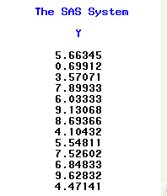

Then I copied this column of random numbers into an Excel spreadsheet aside the names of my students:

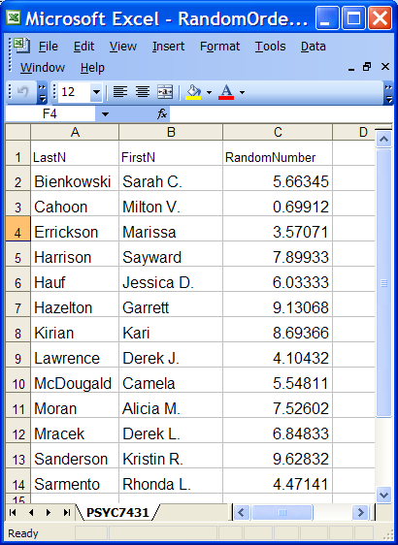

Then I sorted the file by the random numbers:

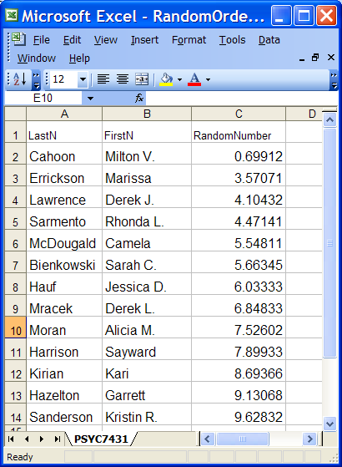

Milton was up first, Kristin last.

Return to Wuensch’s SAS Lessons Page

August, 2018

