SAS and MHT Files

SAS allows one to save output in an MHT (web archive file), which I find a very convenient way to save SAS output with graphics. MHT files are easily read with Internet Explorer, but Microsoft is retiring the Internet Explorer, replacing it with a POS called Edge. By default, Edge will open MHT files, but will not display any of the graphics. I searched the web for a MHT viewer, and found some, but they were very awkward to use and also failed to display SAS graphics. I did, however, discover that Microsoft Word can still open MHT files.

My awesome brother explained to how to make Edge open MHT files properly. You have to tell Edge to reload the document in IE mode. I suspect that option will disappear not long in the future, but glad to have it now.

SAS MHT Output in Edge Default Mode

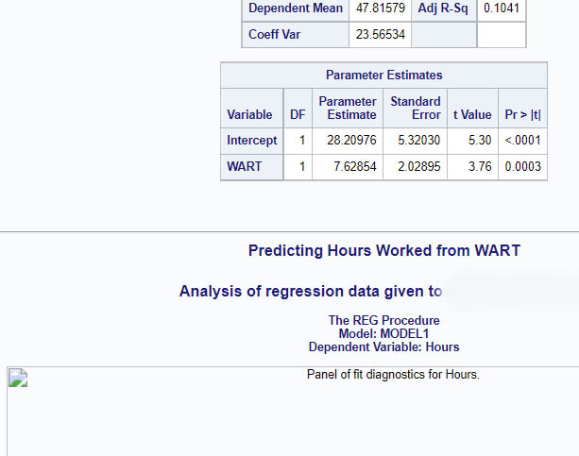

SAS MHT Output in Edge Reloaded in IE Mode

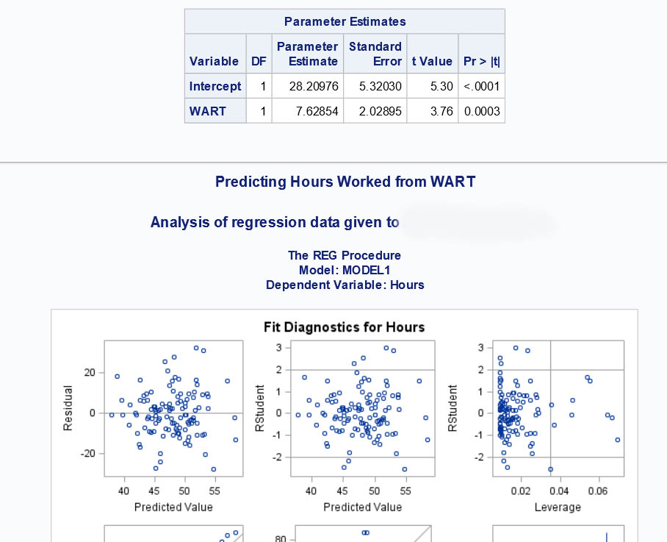

SAS MHT Output Opened in Word

Parameter Estimates
Variable | DF | Parameter  Estimate | Standard  Error | t Value | Pr > |t|
Intercept | 1 | 28.20976 | 5.32030 | 5.30 | <.0001
WART | 1 | 7.62854 | 2.02895 | 3.76 | 0.0003

Predicting Hours Worked from WART
Analysis of regression data given to

The REG Procedure
Model: MODEL1
Dependent Variable: Hours
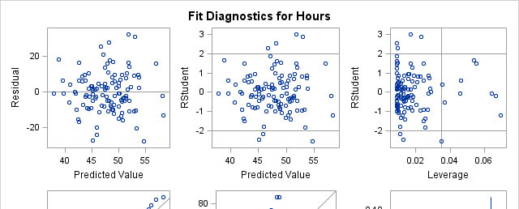

Wuensch’s SAS Lessons Page

Karl L. Wuensch, April, 2022

