Editing an INFILE Statement in SAS

In this SAS program the INFILE statement points to a location on a home computer that I no longer have. To use the program I need to edit the infile statement to point to the location of EDA.dat on the computer I am using now.

*g1g2.sas;
***********************************************************************************;
*Illustrates use of PROC STANDARD to standardize a variable, and;
*The computation of G1, Fisher's skewness, and;
*The computation of G2, kurtosis;
***********************************************************************************;
options pageno=min nodate formdlim='-';
data EDA; infile 'C:\Users\Vati\Documents\_XYZZY\_Stats\StatData\EDA.dat'; input Y;
proc means mean skewness kurtosis N; var Y; run;
***********************************************************************************;
The first step is to find the file on the current computer.

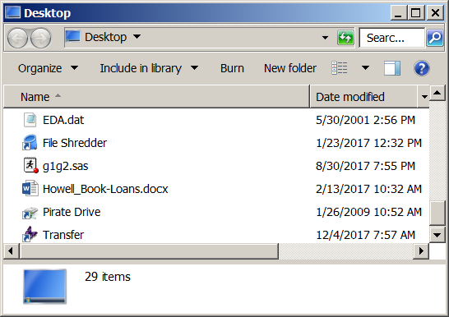

There it is, on the desktop. I right click on the file name and select properties:

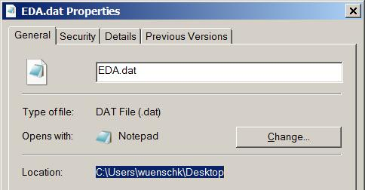

Copy (highlight, Ctrl-C) the path and then paste (Ctrl-V) that into the SAS program.

***********************************************************************************;
options pageno=min nodate formdlim='-';
data EDA; infile C:\Users\wuenschk\Desktop'; input Y;
proc means mean skewness kurtosis N; var Y; run;
***********************************************************************************;
Now, at the end of the path, you need a backslash and the file name, including extension.

***********************************************************************************;
options pageno=min nodate formdlim='-';
data EDA; infile C:\Users\wuenschk\Desktop\EDA.dat'; input Y;
proc means mean skewness kurtosis N; var Y; run;
***********************************************************************************;

