Factor-MR-T -- read the text data into SAS and do additional analyses with them.
options formdlim='-' pageno=min nodate;
title 'Stats on factor scores'; run;
Proc Format; value who 1='Pitt' 2='ECU' ;
data scores; infile 'C:\Users\wuenschk\Documents\StatData\factbeer.dat';
input AesthetQ CheapDr SES Group;
format Group who. ;
proc reg simple corr; model SES=AesthetQ CheapDr / stb scorr2;
proc ttest; class Group; var AesthetQ CheapDr; run;

Stats on factor scores

The REG Procedure
Number of Observations Read | 20
Number of Observations Used | 20

Descriptive Statistics
Variable | Sum | Mean | Uncorrected SS | Variance | Standard  Deviation
Intercept | 20.00000 | 1.00000 | 20.00000 | 0 | 0
AesthetQ | -1.4E-9 | -7E-11 | 18.35862 | 0.96624 | 0.98298
CheapDr | 7E-10 | 3.5E-11 | 18.11589 | 0.95347 | 0.97646
SES | 70.00000 | 3.50000 | 368.00000 | 6.47368 | 2.54434

Correlation
Variable | AesthetQ | CheapDr | SES
AesthetQ | 1.0000 | 0.0028 | 0.6788
CheapDr | 0.0028 | 1.0000 | -0.7161
SES | 0.6788 | -0.7161 | 1.0000

Stats on factor scores

The REG Procedure
Model: MODEL1
Dependent Variable: SES
Number of Observations Read | 20
Number of Observations Used | 20

Analysis of Variance
Source | DF | Sum of  Squares | Mean  Square | F Value | Pr > F
Model | 2 | 120.07462 | 60.03731 | 348.89 | <.0001
Error | 17 | 2.92538 | 0.17208
Corrected Total | 19 | 123.00000

Root MSE | 0.41483 | R-Square | 0.9762
Dependent Mean | 3.50000 | Adj R-Sq | 0.9734
Coeff Var | 11.85218

Parameter Estimates
Variable | DF | Parameter  Estimate | Standard  Error | t Value | Pr > |t| | Standardized  Estimate | Squared  Semi-partial  Corr Type II
Intercept | 1 | 3.50000 | 0.09276 | 37.73 | <.0001 | 0 | .
AesthetQ | 1 | 1.76213 | 0.09682 | 18.20 | <.0001 | 0.68078 | 0.46345
CheapDr | 1 | -1.87085 | 0.09746 | -19.20 | <.0001 | -0.71799 | 0.51550

Stats on factor scores

The REG Procedure
Model: MODEL1
Dependent Variable: SES
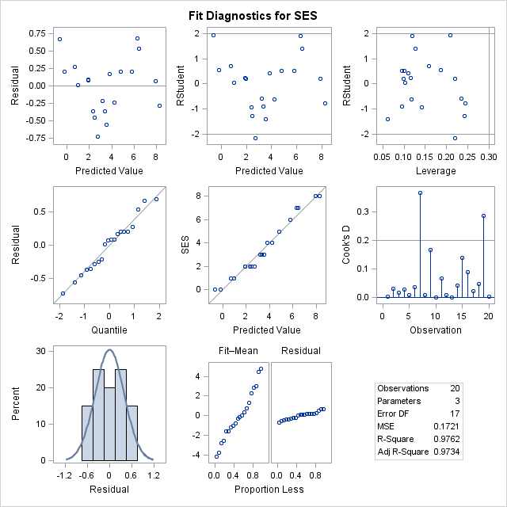

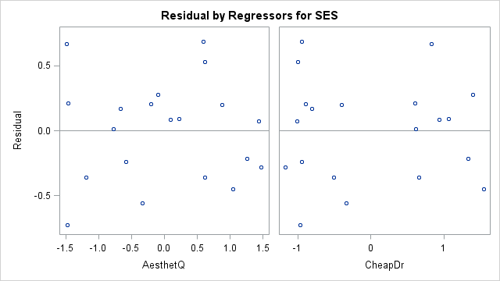

Stats on factor scores

The TTEST Procedure

Variable: AesthetQ
Group | N | Mean | Std Dev | Std Err | Minimum | Maximum
Pitt | 11 | -0.4102 | 0.9936 | 0.2996 | -1.4839 | 1.2606
ECU | 9 | 0.5013 | 0.7393 | 0.2464 | -0.5824 | 1.4706
Diff (1-2) |  | -0.9115 | 0.8896 | 0.3999

Group | Method | Mean | 95% CL Mean |  | Std Dev | 95% CL Std Dev
Pitt |  | -0.4102 | -1.0777 | 0.2574 | 0.9936 | 0.6943 | 1.7438
ECU |  | 0.5013 | -0.0670 | 1.0696 | 0.7393 | 0.4994 | 1.4164
Diff (1-2) | Pooled | -0.9115 | -1.7516 | -0.0714 | 0.8896 | 0.6722 | 1.3156
Diff (1-2) | Satterthwaite | -0.9115 | -1.7269 | -0.0961

Method | Variances | DF | t Value | Pr > |t|
Pooled | Equal | 18 | -2.28 | 0.0350
Satterthwaite | Unequal | 17.879 | -2.35 | 0.0305

Equality of Variances
Method | Num DF | Den DF | F Value | Pr > F
Folded F | 10 | 8 | 1.81 | 0.4138

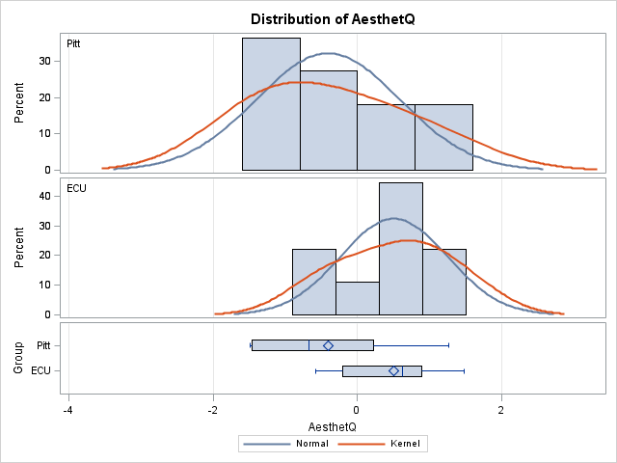

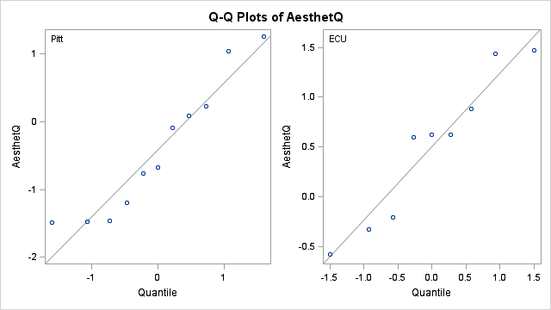

Variable: CheapDr
Group | N | Mean | Std Dev | Std Err | Minimum | Maximum
Pitt | 11 | 0.5491 | 0.9014 | 0.2718 | -0.9731 | 1.5488
ECU | 9 | -0.6711 | 0.5725 | 0.1908 | -1.1716 | 0.6582
Diff (1-2) |  | 1.2201 | 0.7727 | 0.3473

Group | Method | Mean | 95% CL Mean |  | Std Dev | 95% CL Std Dev
Pitt |  | 0.5491 | -0.0565 | 1.1546 | 0.9014 | 0.6298 | 1.5819
ECU |  | -0.6711 | -1.1111 | -0.2310 | 0.5725 | 0.3867 | 1.0967
Diff (1-2) | Pooled | 1.2201 | 0.4905 | 1.9498 | 0.7727 | 0.5838 | 1.1427
Diff (1-2) | Satterthwaite | 1.2201 | 0.5198 | 1.9205

Method | Variances | DF | t Value | Pr > |t|
Pooled | Equal | 18 | 3.51 | 0.0025
Satterthwaite | Unequal | 17.096 | 3.67 | 0.0019

Equality of Variances
Method | Num DF | Den DF | F Value | Pr > F
Folded F | 10 | 8 | 2.48 | 0.2112

