Exporting Data from SAS

File, Import Data. Identify the (member) name of the data to be exported.
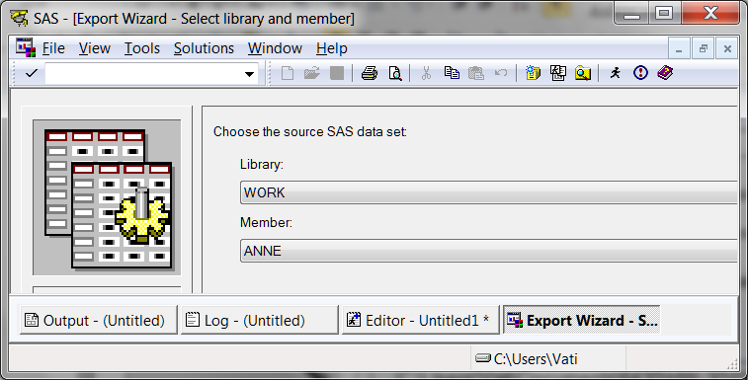

Select the type of file you wish to create. Here I selected Excel xls.
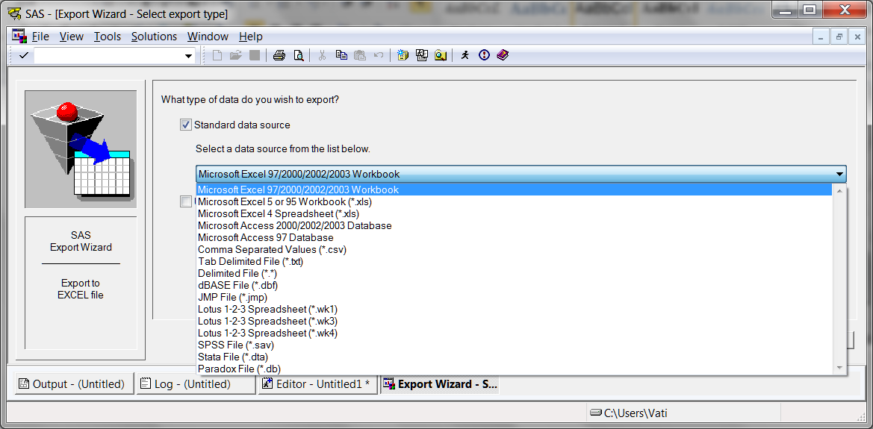

Browse to the folder where you wish to deposit the exported data.
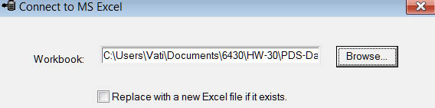

Provide a name for the Excel table being created.
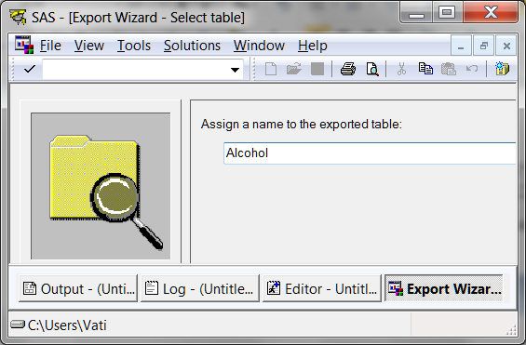

Optionally, ask SAS to create a file with the syntax for exporting these data.
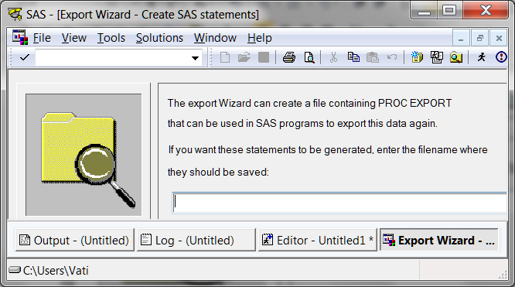

Finish. Check the destination folder. You should find your exported data there.

Return to Wuensch’s Stats Lessons Page
8. Sept. 2011

