Importing to SAS a Delimited, Plain Text Data File

File, Import Data. For data source, select “Delimited File.”
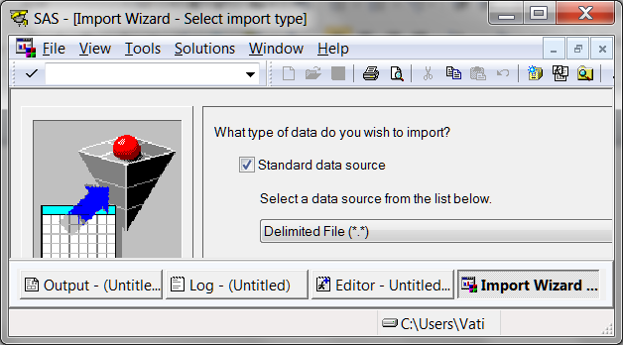

Point to the location of the source file.
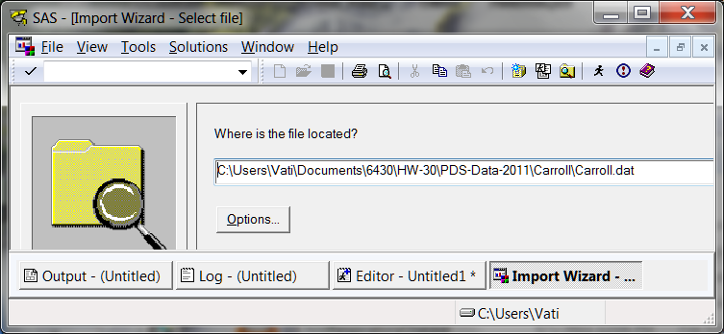

Under Options you can specify the delimiter. The default is a blank space. Indicate whether or not the first row of the input file contains the variable names (I recommend that you do put the names there).
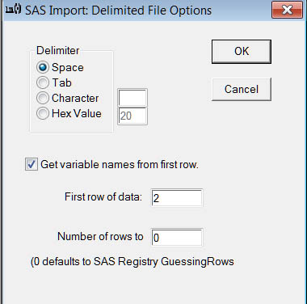

Specify a member name.
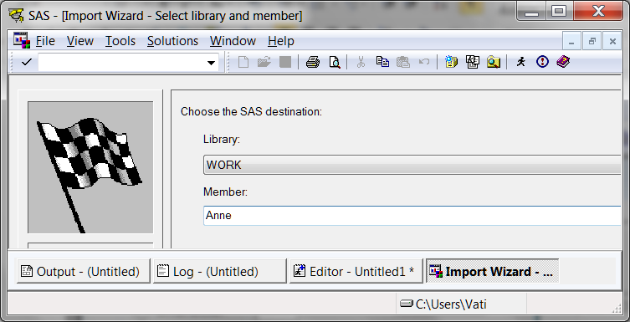

Optionally, ask SAS to write to a file the syntax to import these data.
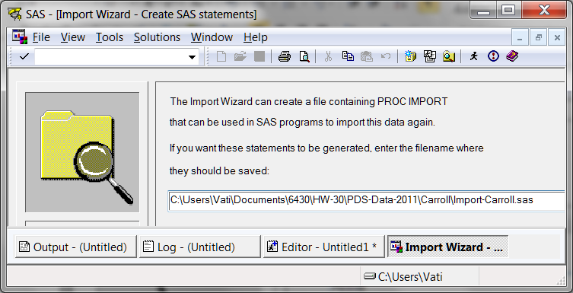

Return to Wuensch’s Stats Lessons Page
8. Sept. 2011

