Column Input in SAS

One of my graduate students desired to work with the data at http://jse.amstat.org/datasets/babyboom.dat.txt . The data are in fixed field format – no delimiter, the scores for each case are in a specified range of columns:
VARIABLE DESCRIPTIONS:
Columns
1 - 8 Time of birth recorded on the 24-hour clock
9 - 16 Sex of the child (1 = girl, 2 = boy)
17 - 24 Birth weight in grams
25 - 32 Number of minutes after midnight of each birth

Here is the code needed to read these data into SAS:

Title 'Baby Boom Column Input'; run;
proc format; value sx 1='Female' 2='Male'; value AP 1='AM' 2='PM';
data BB; infile 'D:\_Stats\StatData\babyboom.dat.txt';
input Time 1-8 sex 9-16 Weight 17-24 MinutesMid 25-32;

The student intended to use these data for an assignment for which the student is required to obtain data on two dichotomous variables and two continuous variables. Regretfully, there is only one dichotomous variable here. I helped out by converting one of the continuous variable to a dichotomous variable:

If 0 LE MinutesMid < 720 then AMPM = 1;
Else if 720 LE MinutesMid LE 1440 then AMPM = 2;
FORMAT sex sx. AMPM AP. ;
Proc Means; run;

The new dichotomous variable, AMPM, has value 1 for all babies born before noon and 1 if noon or later.

Notice that I created the formats before the data step (PROC FORMAT) and applied the formats in the data step (FORMAT). The output from Proc Means looks OK:

Variable | N | Mean | Std Dev | Minimum | Maximum
Time  sex  Weight  MinutesMid  AMPM | 44  44  44  44  44 | 1296.00  1.5909091  3275.95  788.7272727  1.5909091 | 690.7045611  0.4973503  528.0324582  416.0669313  0.4973503 | 5.0000000  1.0000000  1745.00  5.0000000  1.0000000 | 2355.00  2.0000000  4162.00  1435.00  2.0000000

It might be convenient at this point to export the data in an alternate format. I am fond of the SPSS format, do I did that:

Click File, Export Data. Identify the SAS name of the data set, “BB.”
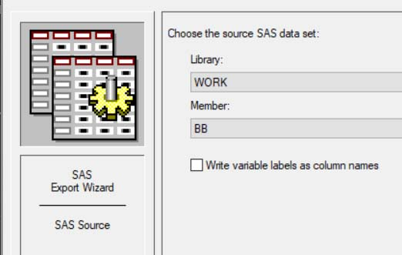

Click next. From the drop-down list, select “SPSS File (*.sav).”

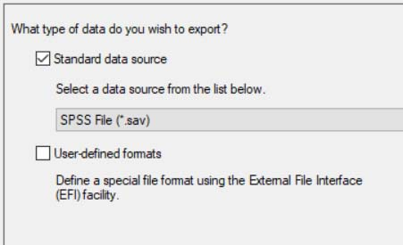

Click Next. Point to where you want to write the exported data.

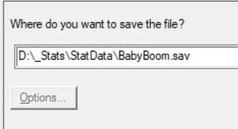

Click Finish.

Open up the SPSS data file to check it out:

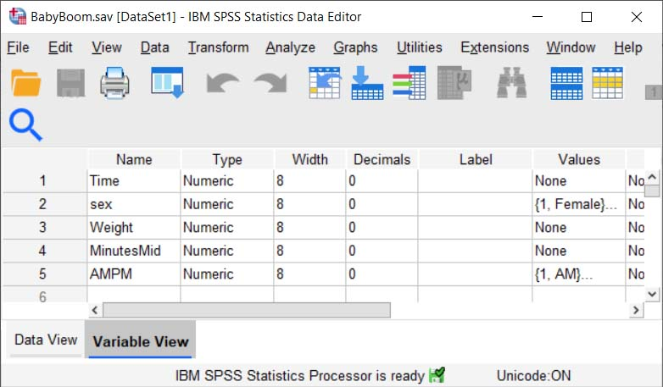

Looks OK. Notice that it includes the Value Labels that were created in SAS.

Karl L. Wuensch, August, 2020.

