Surviving Your Thesis/Dissertation With Your Sanity Intact:
Tips for ECU Psychology Students Using Microsoft Word©

Pagination
This is probably the most frustrating part of getting your thesis/dissertation into the format The Graduate School wants. You want no page numbers on the prefatory pages but you do want them on the following pages, excepting the first page of each chapter.
When you are ready to start the first chapter (the introduction) you should execute a section break (not a regular page break). On the ribbon, select Layout, Breaks, Section Breaks, Next Page.
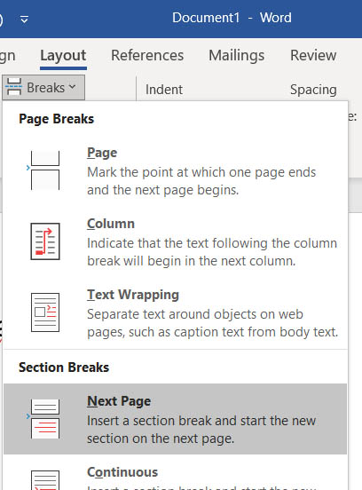

If you have Show/Hide toggled on (highly recommended),
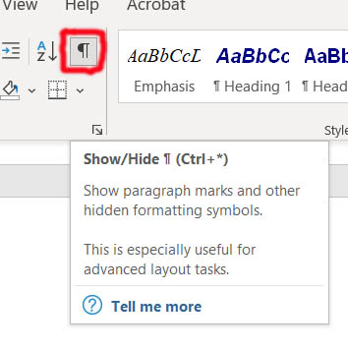

Word will show the section break this way:

On the second page of the first chapter click (on the ribbon) Insert, Footer, Edit Footer.
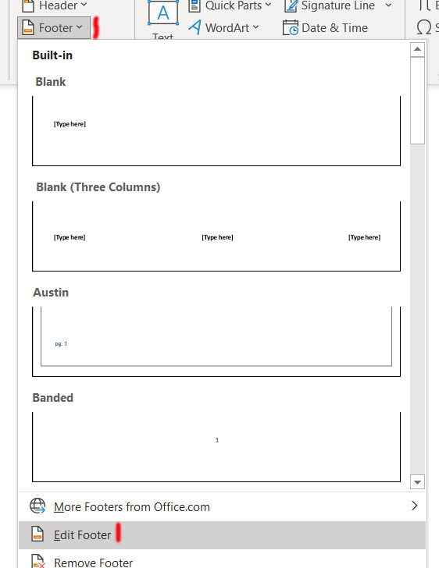

Tell Word to place the footer .75 inch from the bottom, check “Different First Page,” and toggle OFF “Link to Previous.”

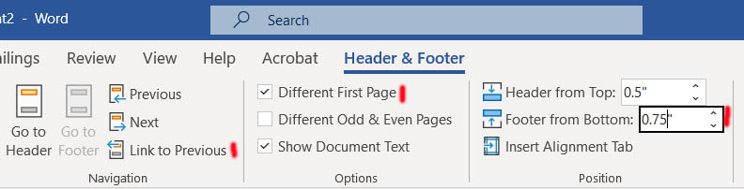

Then click Insert, Page Number, Bottom of Page, Simple, Plain Number 2.
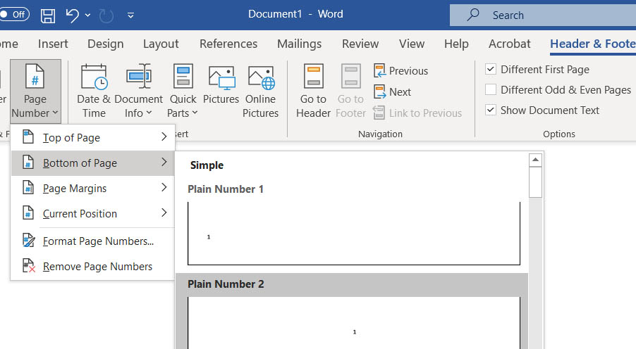
The page number should appear at the bottom of the second page of the first chapter, but not on any of the previous pages, including the prefatory pages. Oops, it should be number 2, but Word will have counted the prefatory pages. Time to fix that.  Select that page number and then Insert, Page Number, Format Page Numbers. | 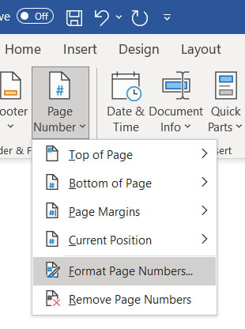

Select “Start at: 1. OK!
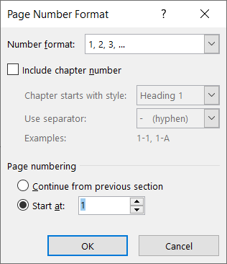

When you start the second chapter you will put in another section break. Word will carry over the settings from the footer in the previous section. One of those settings is to start numbering at 1, but you do not want to keep that setting. Once again, on the section page of the new section, Insert, Page Number, Format Page Numbers. Select “Continue from previous section.”
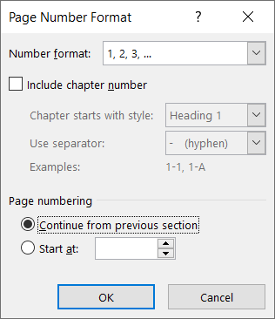

You will put another section break between the second and third chapters. Again, Word will carry over the footer settings from the previous section, but this time that is exactly what you want. It should be smooth sailing from here on.
The silly little document I used to learn how to get the pagination correct can be found here. Looking at it in Word might help you get the pagination correct too.
Changing printers. You would think that your thesis document printed on one printer would be formatted the same as printed on another printer, but that is not so. Word puts soft line and page breaks in different places depending on which printer or printer driver you are using. For example, a line that appears at the top of page 69 when I print in the lab may appear at the bottom of page 68 when I print in my office, despite the fact that I use the same release of Word both places. This, of course, can create problems with the page numbers in the Table of Contents. You will just have to check the page numbers carefully when you print the final copy of the thesis. Imagine the problems created for the student who prints her thesis at home, comes to campus for her defense, has to reprint one page that was damaged or whatever, and finds that page 69 as printed at home differs from page 69 as printed on campus. Imagine the problems encountered by the student and professor who are exchanging drafts via email attachments. The student has everything in order. The professor pulls up the file and finds that a (soft) page break is misplaced or that a section which starts on page 68 according to the Table of Contents actually starts on page 69. The professor writes back to the student advising of the "error," but on the student's end there is no such error.

Double Spacing
While you can use CTRL 2 to set to double space, doing so may create some undesirable effects (especially if working on a APA style manuscript with a header consisting of a short title and page number). You may not get proper spacing between the page numbers and the page text, and other funny things can happen. It is best simply to use Home, Paragraph, Indents and Spacing, Line Spacing, At Least 28 (for a 12 point font). The APA manual says 2 times (font size + 2), that is, 28 with the required 12-point font.
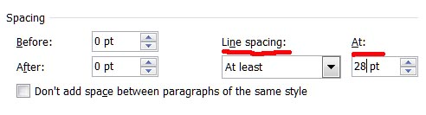
Even without a header, CTRL 2 double spacing can cause problems. I had a document that was OK until I put a hard page break just in front of a centered heading (“Method”). The page breaks got all screwed up (the breaks indicated on the screen were not where they were when printed) and the page numbers indicated at the bottom of the screen were not correct.
I think it best just not to use CTRL 2.

Right Justification of Page Numbers on Table of Contents Page
Don’t use manually inserted dots and blank spaces, use a right tab properly placed at the right margin with a dotted line leader. For my example below, I simply clicked Page Layout, Paragraph, and Tabs (at the bottom left of the window) to get the dialog box. Enter whatever left tabs you desire and then enter a right tab with a leader. Here I entered the tab stop position (I used 6.5) and marked Right Alignment and type 2 Leader (dots). Then I clicked Set, OK. After that, when I hit the tab key after entering the name of a section of the thesis Word drew the dotted leader to the right justified position for the page number.

Chapter II: Method 28
Participants 28
Instrument 29

Left tab stop, no leader | Right tab stop, number 2 leader
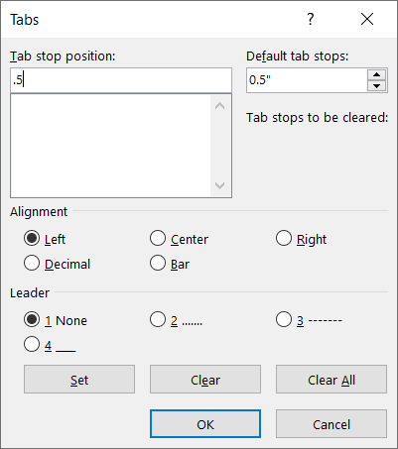 | 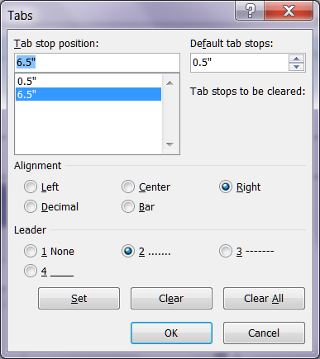

Statistical Symbols
Most statistical symbols are available on the keyboard (just remember to set them in italic font, using CTRL-I or the I button), but some are available only from the special set of symbols available in Word. For example, suppose you wish to report a value of chi-square, such as “χ²(3, N = 369) = 6.23,” .... To get the statistical symbol, click Insert, Symbol. From the drop down box, select More Symbols (unless the one you want is one of the recently used ones already displayed). You can select the font here (regular or symbol are those I most often use). Select the chi-square symbol and click Insert, Close. Hold down Shift Ctrl = to shift to superscript mode and enter the exponent. Hold down Shift Ctrl = to exit superscript mode and continue. APA does not want you to set Greek symbols in italic font, so leave it in the standard font. The Graduate School wants use to use Times New Roman or Arial (my preference) font, so you might want to avoid Symbol font.

Tables
I use Word’s tables feature to create tables in my manuscripts, but a novice should expect to have a lot of trouble using Word’s table command -- once you learn how to use Word tables, it is easy to do things like align numbers in a column or create column spanners.
Column Spanners. Look at the example table below.

Table 1
Gender Differences on the Factor Scores

 | Gender
Factor | Female |  |  |  | Male
 | M |  | SD |  | M | SD
1. Social Interaction  & Emotional Expression  as a Function of Anonymity |  | - .052 | .949 |  | .040 | .952
2. Identity Manipulation & Expressive Outlet |  | - .135ª | .687 |  | .105 | 1.06
3. Companionship & Interaction With Others |  | - .169ª | .805 |  | .131 | .993
4. Information and Learning |  | - .045 | .984 |  | .035 | .878
5. Entertainment & Recreation |  | .052 | .888 |  | - .043 | .876
6. Online Interaction as Supplement to Offline Social Life |  | .011 | .881 |  | - .008 | .905
Note. N = 108 female respondents, 139 male.
ª Significantly different (p < .05) from the mean for male respondents.

Note that I created a blank column between the data for female respondents and that for male respondents, just to provide some blank space there, better to read the table. Tell Word to show rather than hide nonprinting characters (such as carriage returns and blank spaces).
Note how I placed carriage returns to improve the appearance of the table. After creating the main body of the table (rows “1.” through “6.”), I inserted one row above the top row (put cursor in top row, click Table Layout, Insert Above). I typed in the “M” and “SD” in the appropriate cells and used the center icon to center the text in those cells. Then I inserted another row at the top. At this point, the cells in the new row were defined exactly like those in the row below, that is, six cells. In the cell just above the “M” for the data from female respondents, I typed in “Female.” Then I highlighted that cell and the cell to its right and clicked Table Layout, Merge Cells. Zap, those two cells became one. I centered the text in the merged cells and moved on to create the “Male” cell in the same fashion. Then I added another new row at the top of the table, typed “Gender” in the second from left cell, highlighted all but the leftmost cell, merged those cells, and centered the text. Now the borders at the top and bottom of the table, the table spanner (a line the entire width of the table), and the column spanners (under decked heads, like “Gender,” “Female,” and “Male”) were easily created by highlighting the row or the cells where I wanted the line drawn and then using the borders icons to place the lines. Click the arrowhead to the right of the borders icon and then choose the type of border you wish to apply or remove:
The borders icon appears in Home, Paragraph, here in the lower right. | 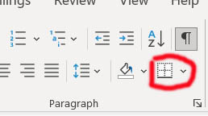

Aligning numbers in columns. So how did I get the numbers to line up by their decimal points? Easy, here is how to do it:

- Highlight the data cells in the column with which you are working:
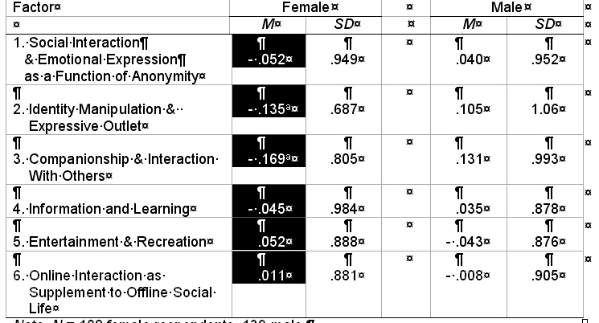
- Be sure that alignment is set to left (not centered):
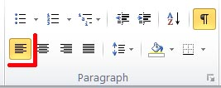
- If the ruler is not already showing, click View Ruler to display it. Repeatedly click on the icon to the left of the ruler until it shows the symbol for decimal tab, like this:
- On the ruler click where you want a tab. You might need more precise control that you can achieve using the GUI interface. Use the tab control window. For each cell in the column put the cursor to the left of the number, hold down the CTRL key, and hit the TAB key.
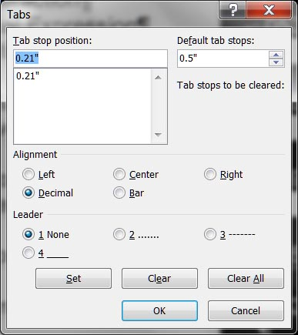
I can’t do it! If you are unable to learn how to use Word tables to make APA-style tables with proper column spanners, alignment, etc., and you value your sanity, consider the following two options: a.) hire a professional to do it for you b.) do it the old fashioned way, as one would on a typewriter. The old fashioned way is to make the tables in plain text (rather than in a Word table), typing in lines for column spanners, and using spaces to produce alignment. Remember that if you are using a proportional font (like Times New Roman), you cannot use spaces to produce proper alignment. With a proportional font, different characters take up different amounts of space, so you cannot produce proper alignment by inserting spaces. Were you to employ the old fashioned method, you would need to change to a fixed font, like Courier. Of course, you would have to use the same font throughout the thesis, and Courier does take up more space (your thesis would become even longer in terms of pages).

Hanging Paragraphs in the Reference List
Do not use hard carriage returns and tabs to produce hanging paragraphs. Do it this way instead:
- Go ahead and type the first reference with no indentation.
- Put the cursor in the body of the reference.
- Look at the ruler
In the box to the left of the ruler is an icon that indicates what type of tab is to be set. You want the 90 degree angle icon that points to the right. If you point at the icon, the words "Left Tab" will appear. If another type of tab is displayed, click the icon repeatedly until the left tab appears.
- Now point at the ruler 2 or 3 clicks from the left margin and hold down the left mouse button. A left tab icon will appear on the ruler and a vertical, dashed line will appear in the body of the document. Move the tab until the dashed line is drawn where you want the tab (indentation) to be located. Release the mouse button. The screen should now look like this:
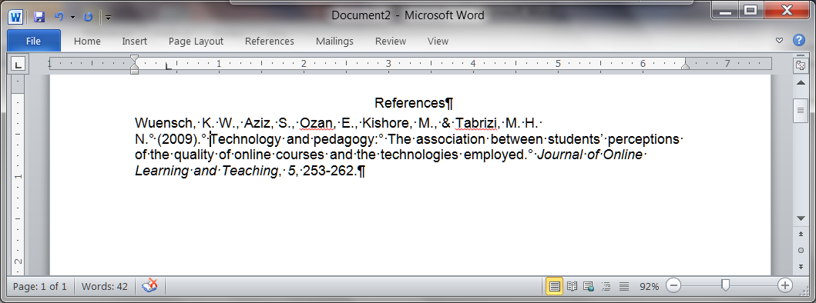

- Now, with the cursor still within the reference, hold down the Ctrl key while you hit the T key. The reference will now show hanging indentation, like this:
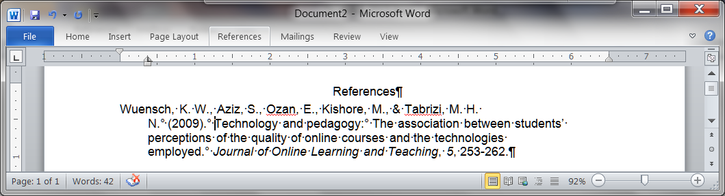

- Place the cursor at the end of the reference, between the period and the hard carriage return icon. Hit Return. Now just go ahead and type the second reference.
- If you ever need to remove hanging indentation, one way to do so is to hold down both the Shift and the Ctrl keys while you hit the T key.

Other Word Tips
If you have other tips that you think would be helpful, please give them to me for consideration for inclusion in this document. If you think there are errors in this document, please let me know about them. Thanks.

Return to the Thesis/Dissertations Tips Page

Karl L. Wuensch, Department of Psychology,
East Carolina University, Greenville, NC 27858 USA
April, 2022.

© Copyright 2022, Karl L. Wuensch - All rights reserved.

