Hanging Indentation in the APA-Style Reference List

Do not use hard carriage returns and tabs to produce hanging paragraphs. Do it this way instead:
- Go ahead and type the first reference with no indentation.
- Put the cursor in the body of the reference.
- Look at the ruler (if you see no ruler, click View, Ruler to make it appear) In the box to the left of the ruler is an icon that indicates what type of tab is to be set. You want the 90 degree angle icon that points to the right. If you point at the icon, the words "Left Tab" will appear. If another type of tab is displayed, click the icon repeatedly until the left tab appears.
- Now point at the ruler 2 or 3 clicks from the left margin and hold down the left mouse button. A left tab icon will appear on the ruler and a vertical, dashed line will appear in the body of the document. Move the tab until the dashed line is drawn where you want the tab (indentation) to be located. Release the mouse button. The screen should now look like this:
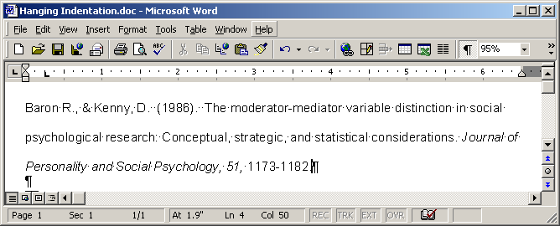

- Now, with the cursor still within the reference, hold down the Ctrl key while you hit the T key. The reference will now show hanging indentation, like this:
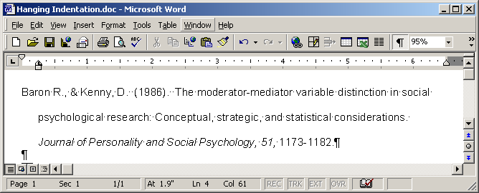

- Place the cursor at the end of the reference, between the period and the hard carriage return icon. Hit Return. Now just go ahead and type the second reference.
- If you ever need to remove hanging indentation, one way to do so is to hold down both the Shift and the Ctrl keys while you hit the T key.

Karl L. Wuensch

