Using SendSpace to Make Large Files Available to Others

You do not need to register, you do not need to download any software, and you do not need to pay anything, for the basic service, which is good.

Go to http://www.sendspace.com/
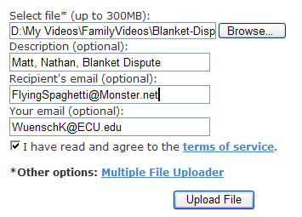
Point to the file to be sent. Optionally, give a description, recipient email address, and your email address. Click “Upload File.”

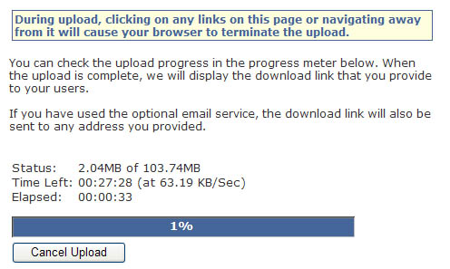

Find something else to do while the file is uploading.

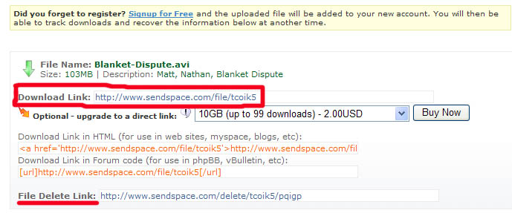

After the upload is complete, you are given the url which can be used to download the file. It is also provided within html code, in case you wish to paste it into a web document. Also provided is a url for deleting the file. If you provided email addresses, the download url is also sent to them, like this:
To you
sendspace.com file upload confirmation for WuenschK@ECU.edu
You have successfully uploaded a file called Blanket-Dispute.avi (104 MB), to sendspace.
Description: Matt, Nathan, Blanket DisputeYou can use the following link to retrieve your file: http://www.sendspace.com/file/tcoik5
You can use the following link to delete your file: http://www.sendspace.com/delete/tcoik5/pqigp

To the other email address you provided
sendspace file delivery notification:
You've got a file called Blanket-Dispute.avi, (104 MB) waiting for download at sendspace.com (Your email address was provided by WuenschK@ECU.edu).
Description: Matt, Nathan, Blanket Dispute
You can use the following link to retrieve your file: http://www.sendspace.com/file/tcoik5

I recommend using one of your own email addresses as the other address and then forwarding the notice from there – less likely to get caught in a spam filter and easy to send to multiple recipients.

When one goes to the url provided, there is, at the bottom of a page of ads, a link to download the file:

The uploaded file will remain available until it has not been downloaded even once in a 30 day period.

Return to Wuensch’s Computing Resources Page

