Writing an APA-Style Research Report©

This document was prepared for my students in PSYC 2210, Experimental Psychology, as an introduction to the topic of writing a research report in the style promulgated by the American Psychological Association. This document itself is not written in APA-style.
After you have completed your research, assuming that your results have the potential of being of interest to other people, you need to prepare a report in which you summarize the research. Often times you will already have completed much of the report before you even start collecting data. That is, you will have written a research proposal which outlines the rational for conducting the research and the methods employed for gathering the data. That same information will be included in the final research report.
What You Should Read In Addition To This Document
You should read Chapter 13 in our textbook, David Martin’s Doing Psychology Experiments, which provides a good, but short, explanation of what is involved in preparing a research report.
You should also use the Internet resources which I have listed here:
- Sample Papers for PSYC 2210 – Use these as models of how to prepare an APA-style research manuscript
- Dr. Wuensch’s APA-Style Page -- a collection of links to documents which give you much of the same information that is found in the Publication Manual of the American Psychological Association. Getting this information on the Internet will save you the expense of buying the publication manual yourself or the bother of borrowing it from someone else. When writing research reports for this class, be sure you refer to the resources linked here to minimize the number of errors of style you make in your reports.
- Common Thesis Errors -- although designed for graduate students who are writing a thesis in APA-style, this page can also be useful to the undergraduate student in an experimental psychology class. It lists the sort of errors commonly made in such theses, and many of these are the same type of errors of style, spelling, and grammar that are commonly made by undergraduate students in an experimental psychology class.
- Microsoft Word Tips -- also designed for graduate students writing a thesis or dissertation, this document give tips for using Microsoft Word to prepare a research report. When preparing research reports for my experimental psychology class you will need to use Word to do many of the same things that graduate students do when Word-processing their theses and dissertations.
Guarding the Gates to Scientific Publication
The WOT manuscript presented to you is a first revision of the manuscript. When I mailed the original manuscript to the editor of the Journal of Social Psychology, I was confident that it was nearly perfectly written. As is the usual case, it was returned to me with a request that I make a number of revisions. The Journal of Social Psychology is a refereed journal. What that means is that the editor of the journal sends the manuscript to two or three referees, persons judged to be experts in the area. The job of the referees is to decide whether or not the manuscript should be published. Only rarely will a referee decide that a manuscript should be published without any revisions. Only once in my life has a referee made such a decision with respect to one of my manuscripts. The manuscript was submitted to Behavioral and Neural Biology. One of the two referees returned it to the editor with the comment “publish it as it stands.” In fact, that was this referee’s entire review of the manuscript. The other referee wrote three pages of criticism and recommend that the manuscript not be published. This second referee’s review can be tersely summarized in this way: “The results of this manuscript go against all theory and thus are not to be believed and should not be included in the scientific literature.” Usually in a case like this the editor will send the manuscript to a third reviewer, but in this case the editor simply decided to reject the manuscript. My response was simply to send the manuscript off to a different journal, the Journal of Mammalogy, which accepted it for publication with only minor changes.
Margins, Line Spacing, and Page Headers
OK, you are about to start writing your APA-style research report with Microsoft Word. The first thing you should do is set the margins, line spacing, and page headers. As an example of the title page, look at the title page of my WOT manuscript. If you have access to the APA Publication Manual, see Figure 5.1 for an example.
Margins. Open up Word and start a new document. The margins should be uniform (the same on all sides) and at least one inch (some journals may ask for wider margins).
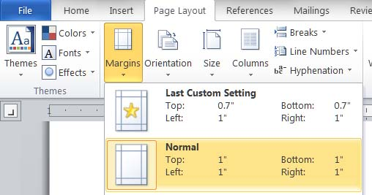
Line Spacing. The manuscript should be double spaced throughout. The easiest way to set the paragraph format to double space in Word is to select the target text (Ctrl-A, holding down the Ctrl key while you hit the A key will select the entire document) and then Ctrl-2. Sometimes this causes problems with page breaks and page numbering, so I recommend an alternative method. Select the entire document (if you have entered any text) and then pull up the paragraph dialog box. Set the Line spacing to At least 28 pt.
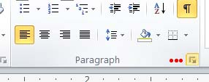

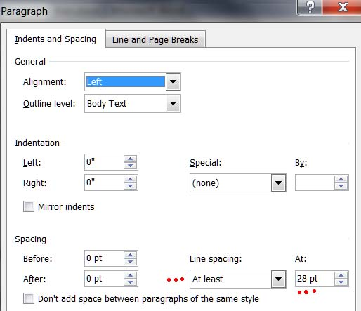

Font. The font should be 12 point. APA recommends Times Roman or Courier. I prefer Arial or Verdana for my handouts, but stick to Times New Roman for my manuscripts.

Page Header. The page header should contain a left justified running head – this is an abbreviated title and should be no longer than 50 characters. The header should also contain the page numbers, right-justified.
To create your page header, double-click in the header area (near the top of the page, which will open the Design tab under Header & Footer Tools. Type the running head in all caps. Now place a right tab at the right margin.
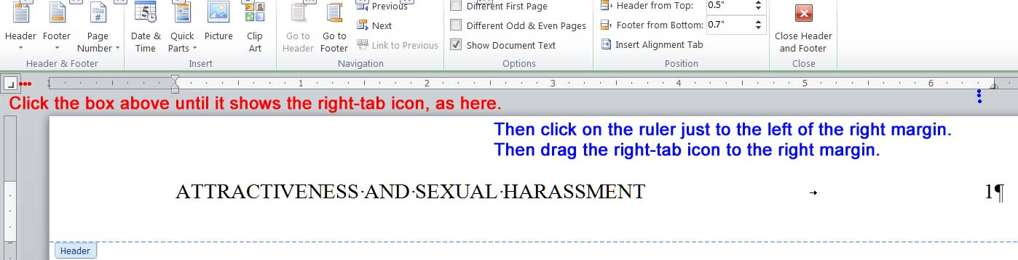
Word may have already put a center tab in the header. If so, grab it (point at it and hold the left mouse button down) and drag it off of the ruler. Now put the cursor just to the right of the running head and hit the tab key. Then Insert, Page Number, Current Position, Simple, Plain Number.
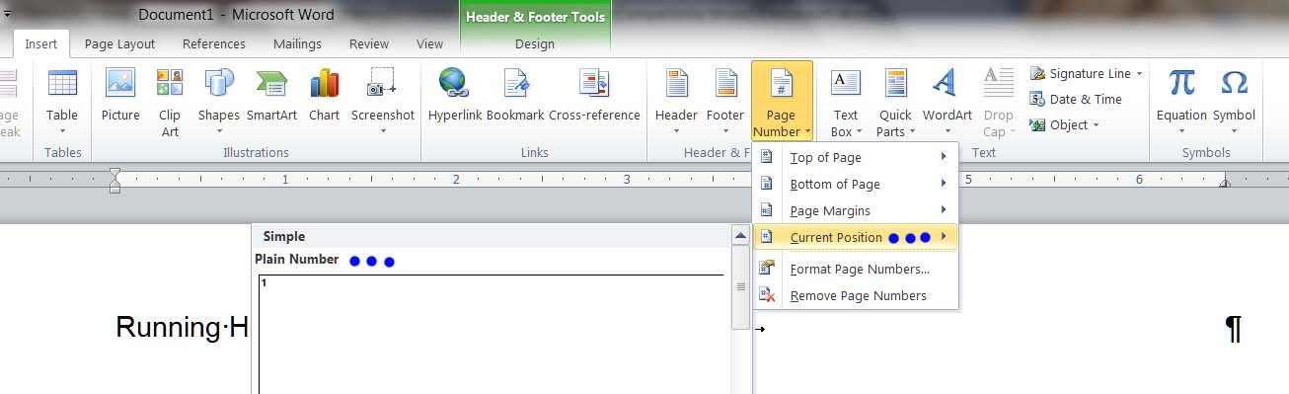

The Title Page
Now you are ready to type the title page, the first page in the manuscript.
Title. Type the title of the research report centered (left to right) positioned in the upper half of the title page. It should be typed in upper and lower case letters. To change the alignment of the title to centered, just highlight it and click the Align Center icon:
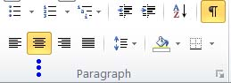
The APA recommends that the title be 10 to 12 words. I commonly find myself exceeding this limit. For the WOT manuscript, the title is 17 words. If your title does not fit on one line, just leave line spacing at double and do not insert an blank line between the first and second lines of the title.
Authors and Institutional Affiliations. The APA says to type the name of the first author on the first double-spaced line below the title. I prefer to put one blank double-spaced line between the title and the name of the first author, as shown in the WOT manuscript. No editor has ever given me grief about this (although they have given me grief about quite a variety of other trivial things). On the next line, type the institutional affiliation of the first author. If there are two or more authors, and the first n authors have the same institutional affiliation, type all of their names on one line followed by the institutional affiliation on the next line. If the institutional affiliation of one author differs from that of the preceding author, put the latter author’s name on a separate line followed by e’s affiliation on the next line. Use upper and lower case for authors’ names and affiliations and center the text left to right.
So, what determines the order of names on a research manuscript in Psychology? The order is supposed to be determined by the relative contributions of the various authors, with the primary contributor being listed first. This is not the case in all disciplines, by the way.
Author Note
The author note appears on the title page. The author note identifies the departmental affiliation of each author and also gives contact information for the author to whom interested parties should write. If the research was funded, the source of such funding is acknowledged here. If any persons other than the authors assisted in the research, their contributions may be acknowledged here too.
Abstract
After finishing your title page, with the cursor at the end of the title page, hold down the Ctrl key and hit the Enter key. This will put in a hard page break. Now you would seem to be ready to type the abstract, which is the second page in a manuscript. The abstract is a short summary of the entire article. Because it summarizes the entire article, it is usually the very last part of the manuscript which is written. The word “Abstract” should appear on the first line, centered. The abstract itself starts on the very next double-spaced line, which should not be indented. Normally an abstract should consist of only one paragraph and should not exceed 120 words. To count the number of words in the abstract, highlight the text of the abstract and then look down at the lower left corner of the window. Word shows how many words there are in the selection and how many there are in the entire document The abstract of my WOT manuscript is 142 words. It was 178 words in the original version and I was scolded for that. It is really hard to summarize an entire research report in only 120 words.
Writing Style
First Person. There is a tradition of psychologists writing in an archaic, overly-formal style, avoiding the first person and using awkward passive voice, as in “the subjects were given instructions by the experimenter,” instead of the less formal “I (or we) instructed the participants ...” This traditional writing style was abandoned many years ago in the biological sciences. Now, finally, the APA has abandoned it too. Those of us who spent many years writing in the old style may have some difficulty breaking that habit, but we should break it.
Italic Font Replaces Underlining. Previously underlining was used in a manuscript to indicate when text should be set in italic font. This is because it was difficult if not impossible to create italic font with a typewriter. Now that we have word processors, that is no longer an issue, so we use italics instead of underlining, as the APA Publication Manual now recommends. To set text in italic font, just highlight the text and Ctrl-I.
Introduction
The abstract should end with a hard page break, with the introductory section of your manuscript starting on the very next page. Do not type the word “Introduction” at the top of this page -- instead, just type the title of the manuscript, in upper and lower case, centered left to right. On the first double-spaced line after the title, start the text of the introduction, left-aligned. Indent the first line of every paragraph.
This section of your manuscript should introduce the reader to the research question(s) that you are posing. Why did you conduct this research? How is your research different from that which has already been done addressing the same or similar questions?
Usually the introduction starts out broad and then narrows in scope. You should review the relevant literature, but not exhaustively. A review article may include an exhaustive and critical review of the literature, but you are not writing a review article, you are writing a research article.
You should end the introduction with a statement of the purpose and rationale of the research you conducted. If your research is not strictly exploratory, you should indicate what results you expected and why you expected such results (based on theoretical considerations and/or the known results of other research you have cited earlier in the introduction. If your research is exploratory, and you had, prior to conducting the research, no idea how the results would come out, say that.
When you do indicate what your predicted results were, stick to what you predicted before you gathered and analyzed the data. In other words, a prediction should be a pre-diction, not a post-diction. Authors sometimes go back and rewrite the introduction after seeing what actually happens, claiming to have predicted what did happen. This is, IMHO, dishonest, although I can understand why some authors do this. Once I obtained a very interesting set of results that were totally unpredicted. My colleagues and I were looking for ways to predict which students would have trouble with introductory courses in Physics for science majors. We did a pretty good job using a battery of tests of various aptitudes and a measure of math anxiety, but, much to our surprise, we found that these predictor variables worked marvelously for predicting the performance of the female students but were essentially worthless for predicting the performance of the male students. Our first manuscript was rejected by the journal to which we sent it. Their objection was that we presented results that were not anticipated. They explained that we should only present results that were relevant to the predictions that we had made, and we had made no predictions of any gender/sex differences. This is, IMHO, BS (bad stuff). I suppose that the reviewers of this manuscript, were they to come home and find a bucket of gold coins on their doorstep, just ignore those coins, since they were unexpected. We sent the manuscript off to another journal, where it was accepted. We did, a posteriori, explain our unanticipated results (in the discussion section of the manuscript), relating them to some prior research and theoretical considerations. Were we dishonest, we would have indicated in the introduction that we expected those gender/sex differences, and the manuscript might then have been accepted for publication by the first journal to which we sent it.
Notice that in my WOT manuscript I did not formally state hypotheses, but I did state what results I expected, at least where I was comfortable with making a prediction. Rarely have I been scolded by reviewers for my style on this matter, and never by journals that publish in the domains of psychology and/or zoology, only by reviewers for journals in the social sciences other than psychology. One should almost never state hypotheses in formal, statistical format -- that is, null and alternative hypotheses. This is, IMHO, archaic, and I will discount your grade if you state hypotheses that way in research reports you write for this class.
Notice that the introduction in my WOT manuscript is three pages in length. Sometimes one will need more than three pages, but rarely does one need more than five pages, IMHO.
Citations
Whenever you refer to the work of another or when you present information that you obtained from another source, you must cite that person/source. You must indicate the source in the text (body of the manuscript) with a brief notation and in the References section of the manuscript in more detail. There must be a one-to-one correspondence between the citations in the text and the entries in the References section -- that is, every source that is cited in the text must also be listed in the References section and vice versa.
Citations in the Text. If you do not have access to the APA Publication Manual, I recommend that you consult the Writer’s Handbook, which has been prepared by and made available on the Internet by the Writing Center at the University of Wisconsin at Madison -- just click on the “Parenthetical citations” link from the main page.
The Reference List. At or near the end of your research manuscript is the References list. Again, if you do not have access to the APA Publication Manual, I recommend the Writer’s Handbook -- click on the “Reference list” link. It is also helpful to have an example manuscript to consult to see how references are given in it. You have access to my WOT manuscript as a model of how references should be formatted.
Headings
A research manuscript can have one to five different levels of headings, but for the typical single-experiment manuscript, two levels should suffice. If you do not have access to the APA Publication Manual, I recommend the Writer’s Handbook, which has been prepared by and made available on the Internet by the Writing Center at the University of Wisconsin at Madison -- just click on the “Headings” link from the main page. Also see my page on APA Headings.
Usually you will not need any subheadings in your introductory section, usually you will in your Methods section, and sometimes you will in your Discussion section.
Method
After you finish the introductory section, hit the Enter key and type the word “Method” on the next line. In a typical one-experiment manuscript (with one, two, or three levels of headings), the headings that describe the major sections of the body of the manuscript (Methods, Results, Discussion) will be Level 1 headings, which are Centered, Boldface, Uppercase and Lowercase. Do not put in a hard page break between the introduction and the next section (unless the journal for which you are preparing the manuscript wants page breaks between sections -- a few do, but most do not).
In the Methods section you describe in detail how you gathered the data. The Methods section is usually divided into subsections.
Participants or Subjects or Research Units. Here you need to identify the units you studied and how you sampled them. When the research units are humans, they are most often referred to as “participants.” For many years the APA prohibited calling humans “subjects,” but now that is OK again. You should report demographic characteristics of your participants, such as sex, age, ethnic identity, and any other available demographics that might help readers determine to what populations your results may generalize well.
Although not typically done in the past, it is a good idea to include in your Method section information on the a priori power analysis that you employed to decide how many subjects should be in your study. For example, you might report that an a priori power analysis indicated that you needed to have 64 subjects in each of your two groups to have 80% power for detecting a medium sized effect when employing the traditional .05 criterion of statistical significance.
Design. Sometimes it is helpful to have a separate section in which you identify the research design that you employed. If your design can be described with a common phrase (such as “2 x 2 factorial design,” “Solomon four-group design”), you may use such a phrase in describing your design. You should identify the variables which you manipulated or measured. In nonexperimental research, you should identify which variable(s) is(are) the criterion variable(s) (that which is predicted) and which variable(s) is(are) the predictor variable(s). In experimental research you identify which variables were treated as independent variables and which as dependent. You should not use the terms “independent variable” and “dependent variable” when describing nonexperimental research. You may identify which variables, if any, are treated as covariates. You may indicate which independent variables are between-subjects variables (independent samples) and which are within-subjects variables (repeated measures). If you matched subjects, indicate what the matching variable(s) is(are). If your statistical analysis involves the testing of hypotheses, it is good form to identify here the decision rule used (most often a .05 criterion of statistical significance).
Research Materials or Apparatus. Here you describe the instruments used for manipulating and measuring variables. If you are employing standardized tests, briefly describe their psychometric characteristics (such as reliability) as know from past research (later, in the Results section, you should report the results of psychometric analysis conducted on the data used in your current study).
Procedure. Here you provide enough detail on the process of data collection to allow another person to repeat your research. How were groups formed, what instructions were given to subjects, how did you manipulate independent variables and measure other variables, and so on.
You do not always need all of the subsections mentioned here. You may combine two or three of them. You may need other subsections.
Results
This is my favorite part of the manuscript, the part where the statistical analyses are presented. The “Results” heading should be typed on the first double-spaced line following the last line of the Method section (no hard page break). If the design and analysis are complex, it may be helpful to break the Results section into subsections, as I did in the WOT manuscript.
Tables and Figures. Tables and figures may be needed best to present the results, especially with complex designs. In a manuscript that is going to be sent to a journal (a so-called “copy manuscript”), tables and figures are referred to in the Results section but they are placed at the end of the manuscript (because they require special handling when the manuscript is being set into type at the journal’s production facility). After the manuscript has been accepted for publication, the workers at the journal will insert the tables and figures at appropriate places within the article, usually in the Results section. A “final manuscript” is one that will reach its final audience in its present form. Theses, dissertations, and the research reports that you will write for this class are final manuscripts. In final manuscripts, tables and figures are placed in the body of the manuscript, just beyond the point to which they are referred (on the same or the next page). It can be difficult managing pages on which both a table or figure and text appears, so you may want to put each table and figure on its own page, the first page after the page on which the table or figure is first referred to.
Descriptive Statistics. Report whatever descriptive statistics (means, standard deviations, correlation coefficients, regression parameters, percentages, and the like) are necessary to support statistical conclusions which are made. Do employ APA-approved statistical abbreviations (see my list of common statistical abbreviations), and do set statistical symbols in italic font (with the exception of Greek letters). While your interest may be mostly with measures of central tendency or location (means and medians), be sure also to present measures of variability/dispersion (standard deviations, range statistics, estimates of error variance).
Tests of Statistical Significance. Usually a Results section includes presentation of the statistics that are used to test statistical hypotheses. For parametric analysis, these include z, t, F, and χ². The degrees of freedom should be given for statistics which have degrees of freedom. For most statistics which have degrees of freedom, there is a simple relationship between sample size (N) and degrees of freedom, so if you have given degrees of freedom, then you do not need to report the N on which that test was based. This is not true, however, of the χ² statistic in its most common applications, so one generally reports both degrees of freedom and N with χ².
Here are some examples of how to report the results of tests of statistical significance. Note that in each case I have indicated whether or not the test is statistically significant and I have reported who the subjects are (unless that is obvious without explicitly stating it), what the variables are, the basic descriptive statistics, the identity of the test statistic employed, the degrees of freedom and/or N, and the exact (to two or three decimal points) p value. For significant results I have also made explicit the direction of the obtained effect. Note that I have included strength of effect estimates and confidence intervals on those estimates.
- For the defendant, the attractive photograph was rated significantly more attractive (M = 7.86, SD = 1.29) than the unattractive photograph (M = 2.90, SD = 1.74), t(322) = 29.15, p = .000, d = 3.24, 95% CI [2.91, 3.57].
- A three way factorial ANOVA was employed to evaluate the effects of gender of juror, race of plaintiff, and race of defendant upon certainty of guilt. The significant effects were gender of juror, F(1, 153) = 5.49, p = .020, η_{p}² = .035, 90% CI [.003, .094]; Gender of Juror x Race of Defendant, F(1, 153) = 4.87, p = .029, η_{p}² = .031, 90% CI [.002 .088]; and Gender of Juror x Race of Plaintiff, F(1, 153) = 6.01, p = .015, η_{p}² = .038, 90% CI [.004, .098], with a MSE of 2.90 for each of these effects. Female jurors were significantly more certain of the defendant’s guilt (M = 6.30) than were male jurors (M = 5.70), d = .35, CI_{.95} = .035, .658. The significant interactions were investigated further by evaluating the simple main effects of race separately for female and male jurors.
- White male jurors were significantly more certain of the guilt of black defendants (M = 6.07) than of white defendants (M = 5.29), F(1, 75) = 4.50, MSE = 3.029, p = .037, d = .43, η_{p}² = .057, 95% CI for η_{p}² [.002, .157], and more certain when the plaintiff was white (M = 6.20) than when she was black (M = 5.18), F(1, 75) = 7.48, MSE = 3.029, p = .008, d = .57, η_{p}² = .091, 95% CI for η_{p}² [.014, .202].
- Female jurors returned guilty verdicts significantly more frequently (86%) than did male jurors (70%), χ²(1, N = 152) = 5.550, p = .018, odds ratio = 2.63.
- Among nonidealists (n = 91), support for animal rights was significantly related to misanthropy, animal rights = 1.63 + .3 misanthropy, r = .36, p < .001, CI_{.95} = .17, .53. When corrected for attenuation due to lack of perfect reliability in the variables, the r = .42. Among idealists (n = 63), the regression line was flat, animal rights = 2.40 + 0.02 misanthropy, r = .02, p = .87, 95% CI [-.23, .27].
Estimates of Effect Size. The APA now strongly recommends the inclusion of estimates of the strength of effects reported in research manuscript. Among the more commonly employed strength of effect estimators are Cohen’s d, r², η², ω², and odds ratios. In the examples above I have included such estimates of effect size. Please see my document Reporting the Strength of Effect Estimates for Simple Statistical Analyses.
Confidence Intervals. Several prominent statisticians have decried the misuse of NHST (null hypothesis significance testing, that is, statistical hypothesis inference testing) and recommended the reporting of confidence intervals rather than (or at least in addition to) reporting tests of statistical significance. The American Psychological Association also strongly recommends the use of confidence intervals. Nevertheless, you will rarely, if ever, see confidence intervals in research publications in psychology. Researchers are reluctant to change the way they analyze and report their research data, and editors and referees continue to expect research reports to have NHST. On every occasion when I have used confidence interval estimation rather than NHST the editor of the journal to whom I submitted the manuscript has scolded me and demanded that I report tests of statistical significance, even when I had no hypotheses to test!
Here is a short excerpt from a manuscript in which results were presented with confidence intervals: “Bootstrapped confidence intervals (95%) were computed using David Howell's resampling software (Howell, 2002). As shown in Table 1, anti-misbehavior signage, combined with increased monitoring by lab attendants, reduced computer misbehavior in the lab.” The table contained confidence intervals for the medians of three variables at three points in time. Interpretation of the results included noting whether confidence intervals overlapped or not.
Confidence Intervals for Effect Size Estimates. Just recently software has been made available which allows one to put confidence intervals on effect size estimates. This software was not available when I wrote WOT manuscript, so such confidence intervals were not included in that manuscript. The results presented above illustrate a couple of awkward things that can happen when one puts a confidence interval on an effect size estimate:
- An η² which differs significantly from zero at the .05 level can have a 95% confidence interval that includes zero. To make the confidence interval equivalent to the test of significance one should use a 90% confidence interval. Very few people understand this.
- An effect which is significant at the .05 level in a factorial analysis can produce a 90% confidence interval for the effect size estimate that includes zero. In the factorial analysis the variance due to other effects in the model is excluded from the error variance, resulting in a larger absolute value of the test statistic and a smaller p value. When constructing a confidence interval about the effect size estimate, the variance due to other effects is typically put back into the error variance, which can result in the confidence interval including zero. One way to avoid this is to compute partial effect size estimates, which estimates the size of the effect after eliminating variance due to all other effects in the model. Partial η² is such a statistic, but I find it uncomforting that when one sums partial η² across effects e can get a sum of more than 100%.
Discussion
The “Discussion” heading should be typed on the first double-spaced line following the last line of the Results section (no hard page break). In this section you relate your results to your hypotheses (if you had hypotheses) and you discuss the theoretical and practical implications of your results. You may point out similarities and differences between your results and those which have been obtained by others who conducted similar research. If there are limitations to your research which you think should be mentioned, this is the place to do so. Often the results of research raise questions that call for additional research. If you wish to suggest additional research that would logically follow from your results, you can do so in the discussion section -- but if you plan on doing that additional research yourself, you had better get started on it soon, or else somebody else will read your discussion and take your suggestion and do that follow-up research before you do it.
The discussion section is the section that I least like to write. All too often it just seems like a “bullshit” section to me. I frequently am forced by reviewers to add material to my original, terse, discussion section. Some journals will allow you to combine the Results with Discussion/Conclusions into a single section titled Results and Conclusions or Results and Discussion.
References
After finishing your discussion section, with the cursor at the end of the last page of discussion, hold down the Ctrl key and hit the Enter key. This will put in a hard page break. This should be the first hard page break you have used since you put one between the abstract and the introduction. Type the word “References” centered on the first line of the new page and then give bibliographic information for every resource which you cited in the body of the manuscript. Notice that hanging indentation is used in the reference list -- that is, in each paragraph (one reference) each line except the first is indented. See Hanging Paragraphs in the Reference List in my Microsoft Word Tips document for instructions on how to produce hanging indentation in Word.
Please note that there must be a one-to-one correspondence between the reference list and the citations in the body of the manuscript. Each source cited in the body of the manuscript must be included in the reference list and each item in the reference list must be cited in the body of the manuscript at least once.
Notice that the titles of journals and books and the volume numbers of journals are set in italic font. To produce italic font in Word you just highlight the text to be set in italic font and then hold down the Ctrl key while you hit the I key.
Appendixes
An appendix is used to present details that would be distracting were they presented in the body of the article. For example, if your research included a questionnaire that you developed, you might include a copy of that questionnaire in an appendix.
If there is an appendix, it starts on a new page following the last page of the references. The first line of the first page says “Appendix” (centered). On the next line type the title of the appendix, in upper and lower case, centered. If there is more than one appendix, identify them as “Appendix A,” “Appendix B,” et cetera, ordering them in the same order to which they were referred in the body of the manuscript.
Footnotes
Footnotes are strongly discouraged by the APA. If used, for example to acknowledge having received permission to quote, they are presented on a new page that immediately follows the author note page.
Tables
Each table is put on a separate page, with the first table following the footnotes (or, more commonly, the author note, when there are no footnotes). The first line of each table page is “Table n,” where “n” is the number of the table. The next line is the title of the table, in upper and lower case, italic font. If you are going to use a table, you should find an example of a table (in a published article or one of my handouts) whose architecture would be appropriate for the material you wish to include in your table and then you should model your table after that table.
Number your tables in the same order to which they are referred to in the body of the manuscript. Do be sure to refer to each table in the body of the manuscript.
Microsoft Word provides powerful tools for making tables, but learning to use them takes some time.
Figure Captions and Figures
A figure caption is the title for a figure. It also helps to explain the figure. In the manuscript that is sent to the publisher, each figure caption appears on a separate page, with the first figure caption being on the page that follows the last table. The first line says “Figure Caption” (centered). The next line says “Figure 1.” and then the title. If there is a second figure, a page with the second figure caption immediately follows that for the first figure caption. After the last figure caption page the figures themselves follow, each on a separate page. The manuscript page header and the figure number are written on the back of each figure.
The APA suggests that the graphical software that is included with office software does not produce graphs of sufficient quality for publication. Professional grade graphics software is very expensive to purchase and difficult to learn to use. I own no such software, but sometimes borrow some from a colleague if I must use it to prepare a figure. I have been successful at using Microsoft Graph to produce graphs that were accepted by the journals to which I submitted them.
Order of the Various Parts of a Manuscript
In summary, here are how the various parts of a manuscript should be ordered.
- Title Page (page 1)
- Abstract (page 2)
- Introduction (page 3, title of the manuscript typed at the top of the page, centered)
- Method
- Results
- Discussion
- References (new page)
- Appendices (if any, start each on a new page)
- Footnotes (if any, new page)
- Tables (if any, start each on a new page)
- Figure Captions (if any, start each on a new page)
- Figures (each on a separate page)
Copy Manuscript versus Final Manuscript
A copy manuscript is one that is sent to a publisher to be converted into a published article. That is the type of manuscript that I have described above. The published article will not appear the same as the copy manuscript -- for example, the tables and figures will be incorporated into the body of the article rather than put at the end of the manuscript.
A final manuscript is one that is already in the form in which it will be read by its final audience. When students write a thesis, a dissertation, or a paper for a class in experimental psychology, they should prepare it as a final manuscript, not as a copy manuscript.
I would like you to follow APA style in preparing your research report for my experimental psychology class, with the following modifications:
Title Page. Instead of a title page, simply put your name, the class name, the date, and the title of the paper you are submitting at the top of the first page of each paper that you submit to me. For example,
Ima Student
PSYC 2210
11. July 2011
Ethical Ideology Related to Political Ideology in College Students
Xxxx xx xxx xxxx ............

Appendix. When you submit your Method section, you may need an appendix -- for example, if you propose using a questionnaire of your own construction. When you submit your Results and Conclusions section, you should include an appendix that contains the statistical output.
Author Note. You should not need an author note.
Tables and Figures. Rather than putting them at the end of the manuscript, put them in the body of the manuscript. You may elect to put each one on a separate page or not, but avoid having a table or figure split across pages. Do not put figure captions on a separate page -- rather, put each figure caption right below its associated figure, as I have done in WOT.

Copyright 2011, Karl L. Wuensch - All rights reserved

© Copyright 2011, Karl L. Wuensch - All rights reserved.

