Direct New SAS Output to a New Results File

SAS 9.3 creates, by default, an htm file with your results. It does look a lot better than the old plain text listings. However, in some versions of 9.3, you cannot “Edit, Clear All” like you can with listing output. All of the output from the current session is put into one file. This is very annoying if you, like me, fiddle around for a while until you get the code right for producing the output you wish to save.
As you can see here, the “Clear” option is grayed out. | 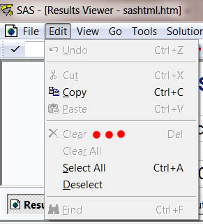

Update, August, 2013: The version of SAS 9.3 installed into our labs this month does include “Edit, Clear All” functionality.
Update, August, 2014. The version of SAS 9.3 installed into Rawl 135 this month does NOT include “Edit, Clear All” functionality, but the version of SAS 9.4 does.
You can, however, close the current output file and start a new one by issuing these commands: “ods html close; ods html;” . You could just execute NewViewer.sas every time you wish to start a new viewer, but it is more convenient to create a new tool to do this. Here is how to do so:

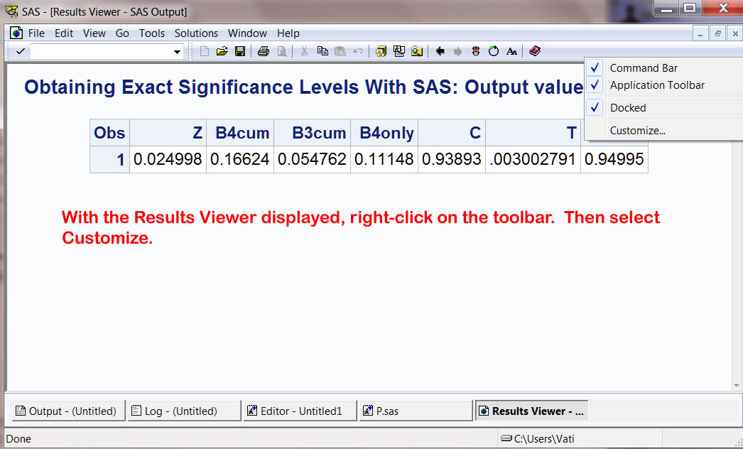

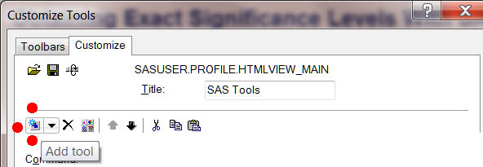

Click on the “Add tool” icon.

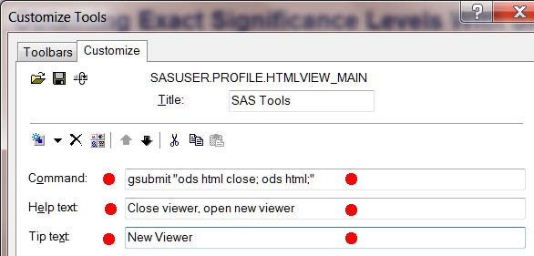

Enter the text shown above.
gsubmit "ods html close; ods html;"

Click OK

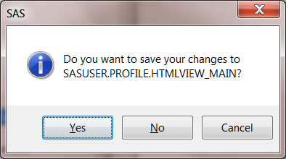

Click Yes. Then go back to the Customize Tools window.

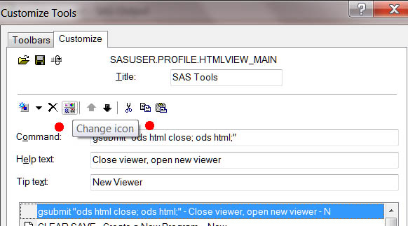

Click on the “Change icon” icon.

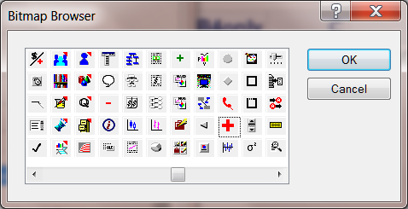
Select the icon you desire and then OK, OK, Yes.

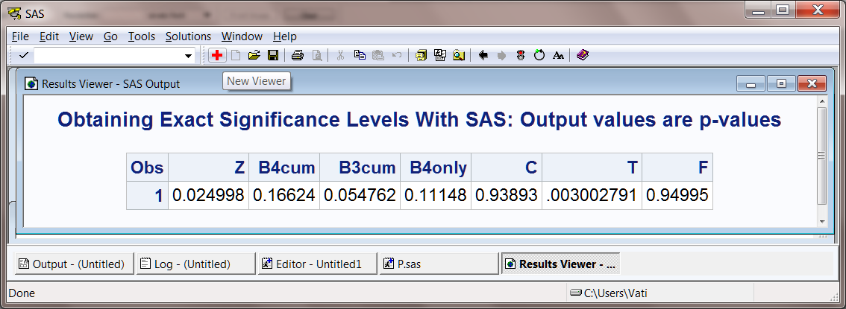

You will now see that icon in the Results Viewer toolbar and can simply click on it every time you wish to direct new output to a new output file.

If you have been using Proc Reg or Proc GLM, SAS may refuse to clear the results window, giving you an error message like this: “Proc GLM is currently executing, blah, blah, blah.” The problem is that a few SAS procedures, like GLM and Reg, are interactive in the sense they are not terminated by the run command. To avoid this problem, when using GLM or Reg, always follow the GLM or Reg commands with a “run;” command and a “quit;” command.

Karl L. Wuensch, September, 2013.

Return to Karl’s SAS Lessons Page

