Concatenating Variables in SAS, SPSS, and Excel

The data here were collected by my brilliant graduate student, Grace Williams. The variables are Male (yes or no), College Student (yes or no), MorningPrepTime (how long does it take you to get ready in the morning), and SleepHours (how much sleep do you get per day).

When variables are concatenated, a new variable is created which has a value equal to the value of the first input variable followed by the value of the second input variable (etc.). Here the two variables are dichotomous, each coded 0,1. The new variable will have values of 00, 01, 10, and 11. It will be a character variable, not a numeric variable.

Proc Format; value $grp 00='Fem Not' 01='Fem Stud' 10='Male Not' 11 = 'Male Stud';
*The format name starts out with $ because it is a character (not numeric) format;
data Grace;
input Male CollegeStud MorningPrepMin SleepHours;
cards;
0 0 20 7
0 0 60 6
1 0 60 6
<snip, snip, I cut the rest of the data out of this document>
;
data Concatenated;
set Grace;
Sex_Student=cats(of Male CollegeStud);
run;
proc print; run;
proc GLM; class Sex_Student; Model MorningPrepMin = Sex_Student / ss1;
Contrast 'Sex' Sex_Student .5 .5 -.5 -.5;
Means Sex_Student; Format Sex_Student $grp.; run; quit;
The SAS System

Obs | Male | CollegeStud | MorningPrepMin | SleepHours | Group
1 | 0 | 0 | 20 | 7.0 | 00
2 | 0 | 0 | 60 | 6.0 | 00
3 | 1 | 0 | 60 | 6.0 | 10
4 | 1 | 0 | 60 | 7.0 | 10
5 | 0 | 1 | 60 | 7.5 | 01
6 | 1 | 0 | 30 | 8.0 | 10
7 | 0 | 0 | 180 | 5.0 | 00
8 | 0 | 1 | 60 | 6.5 | 01
9 | 0 | 1 | 20 | 6.0 | 01
10 | 0 | 0 | 30 | 6.0 | 00
11 | 0 | 0 | 60 | 7.0 | 00
12 | 0 | 0 | 60 | 6.5 | 00
13 | 1 | 1 | 10 | 7.0 | 11
Snip Snip

Here I conducted a one-way ANOVA comparing the four groups created by concatenation.

The GLM Procedure
Class Level Information
Class | Levels | Values
Sex_Student | 4 | Fem Not Fem Stud Male Not Male Stud

Number of Observations Read | 50
Number of Observations Used | 50

Dependent Variable: MorningPrepMin
Source | DF | Sum of Squares | Mean Square | F Value | Pr > F
Model | 3 | 6928.66667 | 2309.55556 | 2.57 | 0.0659
Error | 46 | 41393.33333 | 899.85507
Corrected Total | 49 | 48322.00000

R-Square | Coeff Var | Root MSE | MorningPrepMin Mean
0.143385 | 69.11886 | 29.99758 | 43.40000

Source | DF | Type I SS | Mean Square | F Value | Pr > F
Sex_Student | 3 | 6928.666667 | 2309.555556 | 2.57 | 0.0659

Contrast | DF | Contrast SS | Mean Square | F Value | Pr > F
Sex | 1 | 6400.034453 | 6400.034453 | 7.11 | 0.0105

This contrast compares the two groups of women with the two groups of men.

Level of  Sex_Student | N | MorningPrepMin
 |  | Mean | Std Dev
Fem Not | 18 | 54.4444444 | 41.4760345
Fem Stud | 9 | 52.7777778 | 26.5884269
Male Not | 15 | 34.3333333 | 18.2117178
Male Stud | 8 | 25.0000000 | 16.2568667

Concatenation with SPSS

It is a bit more of a pain than with SAS. One can only do it with string (alphanumeric) variables, so if your classification variables are numeric you have to convert from numeric to string prior to the concatenation. This is a royal pain in the arse, IMHO. Here I shall illustrate how to use Excel to make it a bit less of a pain.
First, export the SPSS data to an Excel file. Open the exported file in Excel. Use Format Cells to change the number of decimal points for the two variables to 0 and then change their format to TEXT. Insert a new column. Then use the CONCATENATE function to put into that new column the joined text columns:

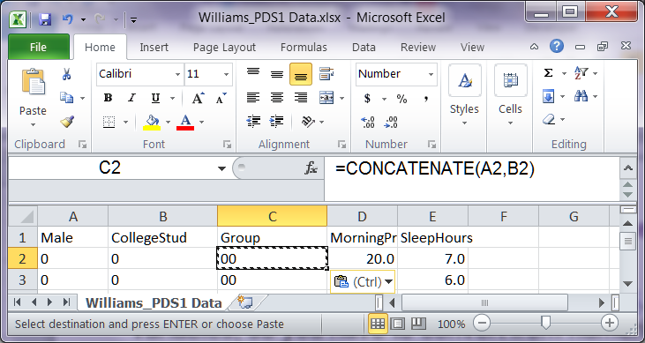

Save the Excel file and then import it into SPSS.

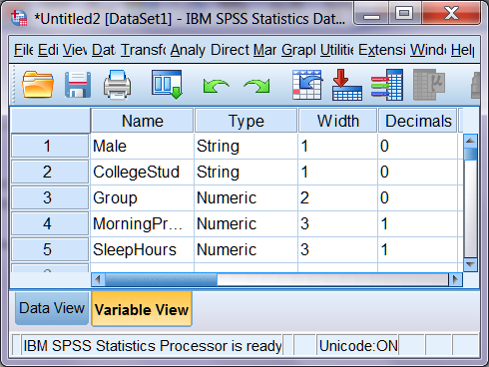

Now you are ready to go.

Return to Wuensch’s SAS Lessons Page

Karl L. Wuensch, January, 2017.

