Installing SAS 9.4
February, 2016, on a Windows 7 PC
This is the worst installation package I have ever seen coming out of SAS. A complete installation takes 4 to 6 hours. Installing SAS 9.3 took me less than an hour. There are 6 DVDs. You do not go through them 1-2-3-4-5-6. Instead, you start with DVD 1, then are told to take it out and put in DVD 2, then are told to take that out and put DVD 1 back in again, then 1 out and 2 in, and it goes on and on like this.
One of the first things you need to do is to select which items you want installed. You are likely to be very confused about what you need and what you do not need, so you elect to install everything. That ends up being 600+ some things. All but one of those seem to have installed successfully -- and the thing that did not install successfully, I have no idea what its function is.
My initial testing of the installation showed that almost all is in order. Two exceptions:
- When you submit syntax, it disappears from the program editor, unless you first highlight all of the syntax. We had this problem with SAS 9.4 all semester long in our labs after it was first installed, and it drove my students, and our ITCS staff, batty. Finally they got it to install correctly. In the labs this problem was accompanied by Java errors and the inability to produce graphical output. Thankfully, I did not encounter that problem after my installation.
- The enhanced editor is not available. No big deal to me.
August, 2019, on a Windows 10 PC
I mistakenly asked to have DBCS included in the installation. This resulted in my only being able to use fonts that were compatible with Japanese. Eventually I found a solution:
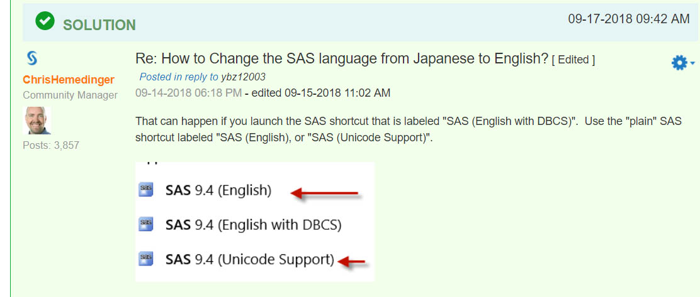

Karl L. Wuensch,

Back to Get SAS/SPSS/AMOS/JMP

