Mitigation, Main Effects, and Moderation

Imagine a study where the variables are
- Level of stress (state)
- Dose, in mg, of a new drug (nopressor) designed to reduce blood pressure.
- SBP, patients resting systolic blood pressure minus the systolic blood pressure considered to be normal/healthy for a person of the subject’s age and sex.

I frequently find my students writing statements (hypotheses) like this: “Dose of nopressor will moderate the effect of stress on systolic blood pressure such that those with high stress will exhibit lower blood pressure when the dose of nopressor is high. That is, nopressor will mitigate the hypertension caused by high stress.” Then I have to explain that the presence of a mitigating effect does not establish moderation.

Consider the data (hypothetical) plotted here. Notice that the conditional effects of stress are identical at all levels of dose of nopressor. There is absolutely no interaction between dose and stress. Nopressor does, however, mitigate the hypertension caused by stress. In simple terms, what we have here is a main effects only model where the effect of dose of nopressor is opposite in direction to the effect of stress.

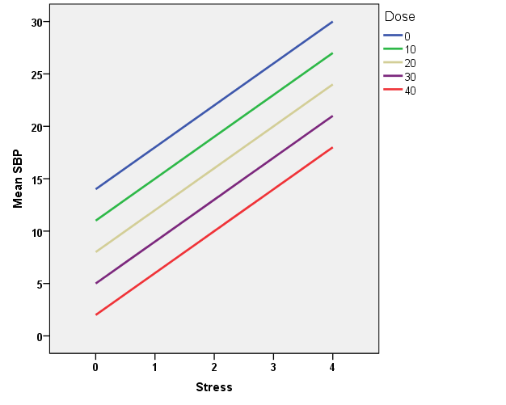

Now consider the (hypothetical) data plotted below:

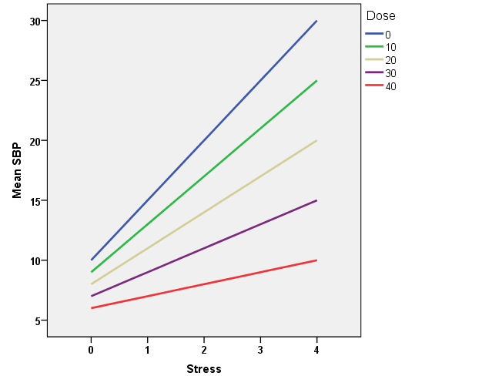

The conditional effects of stress differ across levels of dose of nopressor. There is a Nopressor x Stress interaction – that is, nopressor moderates the effect of stress. More specifically, the greater the dose of nopressor, the weaker the relationship between stress and SBP.

Karl L. Wuensch, March, 2015.

Wuensch’s Stats Lessons

