The Multivariate Approach to the One-Way Repeated Measures ANOVA©

Analyses of variance which have one or more repeated measures/within subjects factors have a SPHERICITY ASSUMPTION (the standard error of the difference between pairs of means is constant across all pairs of means at one level of the repeated factor versus another level of the repeated factor. Howell discusses compound symmetry, a somewhat more restrictive assumption. There are adjustments (of degrees of freedom) to correct for violation of the sphericity assumption, but at a cost of lower power. A better solution might be a multivariate approach to repeated measures designs, which does not have such a sphericity assumption.
Consider the first experiment in Karl Wuensch’s doctoral dissertation (see the article, Fostering house mice onto rats and deer mice: Effects on response to species odors, Animal Learning and Behavior, 20, 253-258. Wild-strain house mice were at birth cross-fostered onto house-mouse (Mus), deer mouse (Peromyscus) or rat (Rattus) nursing mothers. Ten days after weaning each subject was tested in an apparatus that allowed it to enter tunnels scented with clean pine shavings or with shavings bearing the scent of Mus, Peromyscus, or Rattus. One of the variables measured was how long each subject spent in each of the four tunnels during a twenty minute test.
The data are in the file “TUNNEL4b.DAT” and a program to do the analysis in “MAN_RM1.SAS,” both available on my web pages. Run the program. Time spent in each tunnel is coded in variables T_clean, T_Mus, T_Pero, and T_Rat. TT_clean, TT_Mus, TT_Pero, and TT_Rat are these same variables after a square root transformation to normalize the within-cell distributions and to reduce heterogeneity of variance.
proc anova; model TT_clean TT_mus TT_pero TT_rat = / nouni;
repeated scent 4 contrast(1) / summary printe;
proc means; var T_clean -- T_Rat;
Note that PROC ANOVA includes no CLASS statement and the MODEL statement includes no grouping variable (since we have no between subjects factor). The model statement does identify the multiple dependent variables, TT_clean, TT_Mus, TT_Pero, and TT_Rat, and includes the NOUNI option to suppress irrelevant output. The REPEATED statement indicates that we want a repeated measures analysis, with SCENT being the name we give to the 4-level repeated factor represented by the four transformed time variates. “CONTRAST(1)” indicates that these four variates are to be transformed into three sets of difference scores, each representing the difference between the subject’s score on the 1st variate (tt_clean) and one of the other variates—that is, clean versus Mus, clean versus Peromyscus, and clean versus Rattus. I chose clean as the comparison variable for all others because I considered it to represent a sort of control or placebo condition. The SUMMARY option produces an ANOVA table for each of these contrasts and the PRINTE option gives me a test of the sphericity assumption.
There are other CONTRASTS I could have chosen, and with respect to the omnibus univariate and multivariate tests performed by PROC ANOVA, choice of CONTRAST has no effect -- the multivariate test statistics are based on an orthogonal set of contrasts. Had I specified “PROFILE” instead of “CONTRAST(1),” the contrasts reported in the summary table would be clean versus Mus, Mus versus Peromyscus, and Peromyscus versus Rattus (each level of the repeated factor contrasted with the next level of that factor). “POLYNOMIAL” could be used to do a trend analysis (to determine whether the effect of the repeated factor is linear, quadratic, cubic, etc.) if the repeated factor had a quantitative metric (such as 1 month after treatment, 2 months, 3 months, etc. or 1 mg dose of drug, 2 mg, 3 mg, etc.). “HELMERT” would contrast each level of the repeated factor with the mean of all subsequent levels. “MEAN(n)” would contrast each level (except the n^{th}) with the mean of all other levels.
Look first at the “Sphericity Tests, Orthogonal Components” output from “PRINTE.” Mauchly’s criterion” yields a large Chi-square with a low p value—that is, we must reject the assumption of sphericity. If we were to use the univariate analysis we would need to adjust the degrees of freedom for effects involving the repeated factor, scent.
The multivariate approach, “MANOVA Test Criteria for the Hypothesis of no scent Effect,” indicates a significant effect of Scent, F(3, 33) = 7.85, p = .0004. The advantage of the multivariate approach is that it does not require sphericity, so no adjustment for lack of sphericity is necessary.
Look at the “Univariate Tests of Hypotheses for Within Subjects Effects.” Scent has a significant effect, F(3, 105) = 7.01, p = .0002, when we do not adjust for violation of the sphericity assumption. To adjust, simply multiply both numerator and denominator degrees of freedom by epsilon. Using the very conservative Greenhouse-Geisser epsilon, F(2.35, 82.15) = 7.01, p = .0009 (SAS gives the adjusted p’s).
Howell has suggested using the Huynh-Feldt epsilon rather than the more conservative Greenhouse-Geisser when there is reason to believe that the true value of epsilon is near or above 0.75. For these data, the df using the Huynh-Feldt would be 2.53, 88.43. As you can imagine, some so-called “expert” reviewers of manuscripts still think that df can only come in integer units, so you might want to round to integers to avoid distressing such experts.
The “Analysis of Variance of Contrast Variables” gives the results of the planned comparisons between the clean tunnel and each of the scented tunnels. See the untransformed means from PROC MEANS. The mice spent significantly more time in the Mus-scented tunnel than in the clean tunnel, F(1, 35) = 7.89, p = .0008, but the time in the clean tunnel did not differ significantly from that in either of the other two scented tunnels. If desired, one could apply “a posteriori” tests, such as the Tukey test, to the four means. These could be simply computed by hand, using the methods explained in Howell and in my handout on multiple comparisons. The appropriate pooled error term would be the MSE from the omnibus univariate ANOVA, 69.78 on 105 df. If you decided that separate error terms would be better (a good idea when the sphericity assumption has been violated), you could just compute correlated t-tests and use the Bonferroni or Sidak inequality to adjust downwards the p-criterion for declaring the difference significant.

Example of Pairwise Contrasts
data multi; input block1-block3; subj = _N_;
B1vsB3 = block1-block3; B1vsB2 = block1-block2; B2vsB3=block2-block3; cards;
.......scores.......
proc means t prt; var B1vsB3 B1vsB2 B2vsB3; run;
The second part of the program includes a hypothetical set of data, the number of errors made by each of six subjects on each of three blocks of learning trials. In addition to an omnibus analysis, you want to make pairwise comparisons. One method is to construct a difference score for each contrast and then use PROC MEANS to test the null that the mean difference score is zero in the population (that is, conduct correlated t tests). Since there are only three conditions, and the omnibus ANOVA is significant, we need not adjust the per comparison alpha.
Another method is to convert the data from a multivariate setup to a univariate setup (the commands necessary to convert multivariate-setup data to univariate-setup data are detailed in Chapter 16 of Cody and Smith’s Applied Statistics and the SAS® Programming Language, 4th edition) and then use one of the pairwise options on the MEANS statement of PROC ANOVA. This will allow you to use a pooled error term rather than individual error terms, which, as you will see, will give you a little more power. Since we had only three conditions, I chose the LSD (Fisher) option.
Here is the code to convert to a univariate setup:
data univ; set multi;
array b[3] block1-block3; do block = 1 to 3;
errors = b[block]; output; end; drop block1-block3;
proc print; var block errors; id subj;
Look at the output from Proc Print to see how the data look after being converted to univariate format.

SPSS: Point and Click
Obtain from my SPSS Data Page the file TUNNEL4b.sav. Bring it into SPSS. Click Analyze, General Linear Model, Repeated Measures. In the “Within-Subject Factor Name” box, enter “scent.” For “Number of Levels” enter “4.”
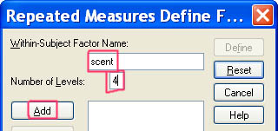
Click Add and then Define. Select t_clean, t_mus, t_pero, and t_rat (these are the transformed variables) and scoot them into the “Within-Subjects Variables” box.
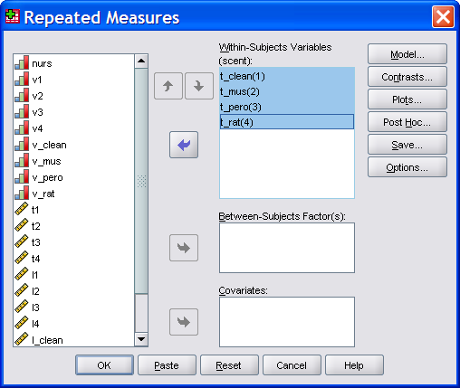
Click Contrasts. Under “Change Contrast” select “Simple” and then select “first” for the “Reference Category.” Click Change.
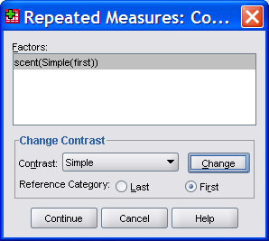
Click Continue.
Other available contrasts are “Helmert” (each level versus mean of all subsequent levels),“Difference” (reverse Helmert, that is each level versus mean of all previous levels), “Polynomial” (trends), Repeated (each level versus the next level), and Deviation (excepting a reference level, each level versus the grand mean of all levels).
Click Plots. Scoot “scent” into the “Horizontal Axis” box.
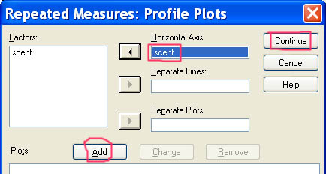
Click Add, Continue.
Click Options. Scoot “scent” into the “Display means for” box. Check “Compare main effects.” If you are afraid that the Familywise Error Boogie Man is going to get you, then change “Confidence interval adjustment” from LSD to Bonferroni or Sidak. I’ll just take the LSD here. Under “Display” check “Estimates of effect size.”
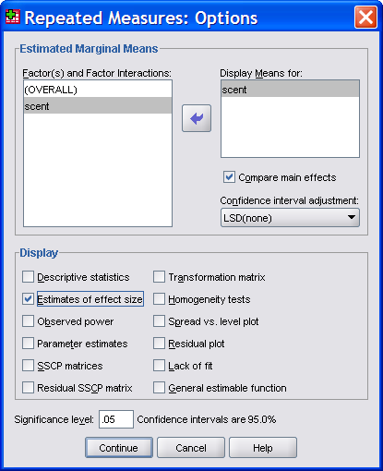
Click Continue, OK.
The omnibus statistical output is essentially the same as that we got with SAS. Look at the “Tests of Within-Subjects Effects.” The “Partial Eta-Squared” here is the scent sum of squares divided by the (scent + error) sum of squares = 1467.267 / (1467.267 + 7326.952) = .167. Look back at the “Multivariate Tests.” The “Partial Eta Squared” here is 1 minus Wilks lambda, 1 - .583 = .417. While this statistic is used as a magnitude of effect estimate in MANOVA, it is clearly not what most people think of when they think of eta-squared.
Contrasts Available
/WSFACTOR=scent 4 Polynomial -- these make no sense here, since the repeated dimension is qualitative, not quantitative

Tests of Within-Subjects Contrasts
Measure: MEASURE_1
Source | scent | Type III Sum of Squares | df | Mean Square | F | Sig.
scent | Linear | 226.426 | 1 | 226.426 | 4.878 | .034
 | Quadratic | 1020.169 | 1 | 1020.169 | 16.942 | .000
 | Cubic | 220.672 | 1 | 220.672 | 2.149 | .152

/WSFACTOR=scent 4 Deviation -- compares each level (except the reference level) to the mean of all levels

Tests of Within-Subjects Contrasts
Measure: MEASURE_1
Source | scent | Type III Sum of Squares | df | Mean Square | F | Sig.
scent | Level 1 vs. Mean | 84.596 | 1 | 84.596 | 1.893 | .178 | Clean-Mean
 | Level 2 vs. Mean | 858.479 | 1 | 858.479 | 9.938 | .003 | Mus-Mean
 | Level 3 vs. Mean | 6.971 | 1 | 6.971 | .131 | .720 | Pero-Mean

/WSFACTOR=scent 4 Deviation(1) -- compares each level(except the first level) to the mean of all levels

Tests of Within-Subjects Contrasts
Measure: MEASURE_1
Source | scent | Type III Sum of Squares | df | Mean Square | F | Sig.
scent | Level 2 vs. Mean | 858.479 | 1 | 858.479 | 9.938 | .003 | Mus-Mean
 | Level 3 vs. Mean | 6.971 | 1 | 6.971 | .131 | .720 | Pero-Mean
 | Level 4 vs. Mean | 517.222 | 1 | 517.222 | 20.647 | .000 | Rat-Mean

/WSFACTOR=scent 4 Simple – Compares each level to the last level

Tests of Within-Subjects Contrasts
Measure: MEASURE_1
Source | scent | Type III Sum of Squares | df | Mean Square | F | Sig.
scent | Level 1 vs. Level 4 | 183.465 | 1 | 183.465 | 2.314 | .137 | Clean-Rat
 | Level 2 vs. Level 4 | 2708.403 | 1 | 2708.403 | 18.305 | .000 | Mus-Rat
 | Level 3 vs. Level 4 | 644.285 | 1 | 644.285 | 7.828 | .008 | Pero-Rat

/WSFACTOR=scent 4 Simple(1) – Compares each level to the first level

Tests of Within-Subjects Contrasts
Measure: MEASURE_1
Source | scent | Type III Sum of Squares | df | Mean Square | F | Sig.
scent | Level 2 vs. Level 1 | 1482.050 | 1 | 1482.050 | 7.886 | .008 | Mus-Clean
 | Level 3 vs. Level 1 | 140.135 | 1 | 140.135 | 1.159 | .289 | Pero-Clean
 | Level 4 vs. Level 1 | 183.465 | 1 | 183.465 | 2.314 | .137 | Rat-Clean

/WSFACTOR=scent 4 Difference – Compares each level to all previous levels combined.
Tests of Within-Subjects Contrasts
Measure: MEASURE_1
Source | scent | Type III Sum of Squares | df | Mean Square | F | Sig.
scent | Level 2 vs. Level 1 | 1482.050 | 1 | 1482.050 | 7.886 | .008 | Mus-Clean
 | Level 3 vs. Previous | 54.921 | 1 | 54.921 | .447 | .508 | Pero vs Clean & Mus
 | Level 4 vs. Previous | 919.505 | 1 | 919.505 | 20.647 | .000 | Rat vs all others

/WSFACTOR=scent 4 Helmert – Compares each level to all later levels combined.
Tests of Within-Subjects Contrasts
Measure: MEASURE_1
Source | scent | Type III Sum of Squares | df | Mean Square | F | Sig.
scent | Level 1 vs. Later | 150.392 | 1 | 150.392 | 1.893 | .178 | Clean vs all others
 | Level 2 vs. Later | 1548.496 | 1 | 1548.496 | 9.506 | .004 | Mus vs Pero & Rat
 | Level 3 vs. Level 4 | 644.285 | 1 | 644.285 | 7.828 | .008 | Pero vs Rat

/WSFACTOR=scent 4 Repeated
Tests of Within-Subjects Contrasts
Measure: MEASURE_1
Source | scent | Type III Sum of Squares | df | Mean Square | F | Sig.
scent | Level 1 vs. Level 2 | 1482.050 | 1 | 1482.050 | 7.886 | .008 | Clean-Mus
 | Level 2 vs. Level 3 | 710.732 | 1 | 710.732 | 3.246 | .080 | Mus-Pero
 | Level 3 vs. Level 4 | 644.285 | 1 | 644.285 | 7.828 | .008 | Pero-Rat

SPSS: Syntax
If you are willing to deal with the syntax of SPSS’ MANOVA utility, you can do more with your repeated measures ANOVA than you can using the point and click interface. Here is the code to do a one-way analysis with some special contrasts on our tunnel4b data. Assuming you already have the data file open, all you have to do is copy and paste this code into the syntax window.
manova t_clean to t_rat / wsfactors = scent(4) /
contrast(scent)=special(1,1,1,1, -3,1,1,1, 0,-2,1,1, 0,0,-1,1) /
rename=overall c_vs_mpr m_vs_pr p_vs_r / wsdesign = scent /
print=transform signif(univ) error(cor) / design /
The “wsfactors” indicates that I call the repeated factor ‘scent’ and it has 4 levels. “contrast(scent)” is used to specify which sort of contrasts I wish to make, if any. You can choose from the same contrasts available with the point and click GLM analysis, or you can provide your own special contrast coefficients, but they must be orthogonal. The first set of coefficients should be K 1’s (where K is the number of levels of the repeated factor), then the next K-1 sets each have K coefficients specifying the contrast you want. The set of 1’s specifies the contrast for the “overall mean.” I then contrasted the clean tunnel with the three scented tunnels, the conspecific (Mus) scented tunnel with the two contraspecific tunnels, and the Peromyscus tunnel with the Rattus (a predator upon Mus) tunnel. These orthogonal contrasts actually make some sense. The rename command was used to assign labels to the contrasts.
The wsdesign statement is optional—if omitted MANOVA assumes a full factorial model for the within-subjects factors—if you want other than that you must specify the model you want on the WSDESIGN statement. The design statement with no arguments produces a full factorial model with respect to the between-subjects factors—if you want other than that you must specify the between-subjects effects you want on the design statement.
“Print =” specifies optional output, including “transform”, the contrast transformation matrix (inspect it to verify that the orthogonal contrasts I wanted were those computed), “signif(univ)” to print univariate ANOVAs on the contrasts I specified, and “error(cor)” to obtain the sphericity statistics.
With respect to omnibus univariate and multivariate tests the output is about the same we got from SAS, only formatted differently. The univariate ANOVA on the repeated factor is called an “Averaged F” because it is a pooled F computed with the univariate contrast ANOVA sum of squares and degrees of freedom. Look at univariate statistics and verify that the AVERAGED SCENT SS = the sum of the Hypoth. SS for C_VS_MPR, M_VS_PR, and P_VS_R. Sum the corresponding Error SS and you obtain the AVERAGED WITHIN CELLS SS. Sum the contrast degrees of freedom (1, 35 for each of 3) and you get the AVERAGED F DF (3,105). Note that the clean versus scented contrast is not significant, the Mus versus other-rodent is (the Mus tunnel being most attractive), and the Peromyscus versus Rattus is also significant (the Rattus tunnel not being very attractive).

EFFECT .. SCENT
Multivariate Tests of Significance (S = 1, M = 1/2, N = 15 1/2)

Test Name Value Exact F Hypoth. DF Error DF Sig. of F

Pillais .41656 7.85379 3.00 33.00 .000
Hotellings .71398 7.85379 3.00 33.00 .000
Wilks .58344 7.85379 3.00 33.00 .000
Roys .41656
Note.. F statistics are exact.

- - - - - - - - - - - - - - - - - - - - - - - - - - - - - - - - - - - - - - - - - - - - - - - - - - - - - - - - - - - -
EFFECT .. SCENT (Cont.)
Univariate F-tests with (1,35) D. F.

Variable Hypoth. SS Error SS Hypoth. MS Error MS F Sig. of F

C_VS_MPR 112.79400 2085.92748 112.79400 59.59793 1.89258 .178
M_VS_PR 1032.33073 3800.75328 1032.33073 108.59295 9.50642 .004
P_VS_R 322.14260 1440.27163 322.14260 41.15062 7.82838 .008

Copyright 2019, Karl L. Wuensch - All rights reserved.

Date: Sun, 6 Feb 94 19:45:50 EST
Sender: edstat-l@jse.stat.ncsu.edu
From: eklunn@aix02.ecs.rpi.edu (Neil Holger Eklund)
Subject: Re: Huynh-Feldt epsilon—pronounce?

dfitts@u.washington.edu (Douglas Fitts) writes: How *do* you pronounce it? Hoon? Hi-un? Anyone have a definitive answer?

I’ve allways heard it “Winn-Felt”
===============================================================
From: Elaine Rhodes <erhodes@camelot.bradley.edu>: I believe that it is pronounced something close to “winn” or perhaps “when”.
===============================================================
From: maxwell gwynn f <mgwynn@mach1.wlu.ca>
My understanding is that it’s pronounced as Hine-Felt. I may be wrong, I may be right, I may be crazy.
===============================================================
I was playing on the internet and came across your short piece on randomized block design and noted the chain of emails regarding how to pronounce Huynh’s name. As I was his last student and we still meet for food or a drink, I think I can settle your debate. Huynh Huynh, first and last name, are both pronounced, “Win;” it’s great fun to tell a table, “We’ll order when Huynh Huynh arrives.”

Best,
Brandon

Brandon L. Loudermilk, Education Associate, Office of Assessment
South Carolina Department of Education
April, 2012

Return to Wuensch’s Statistics Lessons Page

© Copyright 2019, Karl L. Wuensch - All rights reserved.

