**A Brief Introduction to Reliability, Validity, and Scaling[1]©**

**Reliability**

Simply put, a reliable measuring instrument is one which gives you the same measurements when you repeatedly measure the same unchanged objects or events. We shall briefly discuss here methods of estimating an instrument’s reliability. The theory underlying this discussion is that which is sometimes called “classical measurement theory.” The foundations for this theory were developed by Charles Spearman (1904, “General Intelligence,” objectively determined and measures. *American Journal of Psychology*, *15*, 201-293).

If a measuring instrument were perfectly reliable, then it would have a perfect positive (*r* = +1) correlation with the true scores. If you measured an object or event twice, and the true scores did not change, then you would get the same measurement both times.

We theorize that our measurements contain **random error**, but that the mean error is zero. That is, some of our measurements have error that make them lower than the true scores, but others have errors that make them higher than the true scores, with the sum of the score-decreasing errors being equal to the sum of the score increasing errors. Accordingly, random error will not affect the mean of the measurements, but it will increase the variance of the measurements.

Our definition of reliability is . That is, reliability is the proportion of the variance in the measurement scores that is due to differences in the true scores rather than due to random error.

Please note that I have ignored **systematic (nonrandom) error**, optimistically assuming that it is zero or at least small. Systematic error arises when our instrument consistently measures something other than what it was designed to measure. For example, a test of political conservatism might mistakenly also measure personal stinginess.

Also note that I can never know what the reliability of an instrument (a test) is, because I cannot know what the true scores are. I can, however, **estimate reliability**.

**Test-Retest Reliability.** The most straightforward method of estimating reliability is to administer the test twice to the same set of subjects and then correlate the two measurements (that at Time 1 and that at Time 2). Pearson *r* is the index of correlation most often used in this context. If the test is reliable, and the subjects have not changed from Time 1 to Time 2, then we should get a high value of *r*. We would likely be satisfied if our value of *r* were at least .70 for instruments used in research, at least .80 (preferably .90 or higher) for instruments used in practical applications such as making psychiatric diagnoses (see my document [Nunnally on Reliability](http://core.ecu.edu/psyc/wuenschk/StatHelp/Reliab-Nunnally.docx)). We would also want the mean and standard deviation not to change appreciably from Time 1 to Time 2. On some tests, however, we would expect some increase in the mean due to practice effects.

**Alternate/Parallel Forms Reliability.** If there two or more forms of a test, we want to know that the two forms are equivalent (on means, standard deviations, and correlations with other measures) and highly correlated. The *r* between alternate forms can be used as an estimate of the tests’ reliability.

**Split-Half Reliability.** It may be prohibitively expensive or inconvenient to administer a test twice to estimate its reliability. Also, practice effects or other changes between Time 1 and Time 2 might invalidate test-retest estimates of reliability. An alternative approach is to correlate scores on one random half of the items on the test with the scores on the other random half. That is, just divide the items up into two groups, compute each subject’s score on the each half, and correlate the two sets of scores. This is like computing an alternate forms estimate of reliability after producing two alternate forms (split-halves) from a single test. We shall call this coefficient the **half-test reliability coefficient, *rhh***.

**Spearman-Brown.** One problem with the split-half reliability coefficient is that it is based on alternate forms that have only one-half the number of items that the full test has. Reducing the number of items on a test generally reduces it reliability coefficient. To get a better estimate of the reliability of the full test, we apply the Spearman-Brown correction,  .

**Cronbach’s Coefficient Alpha.** Another problem with the split-half method is that the reliability estimate obtained using one pair of random halves of the items is likely to differ from that obtained using another pair of random halves of the items. Which random half is the one we should use? One solution to this problem is to compute the Spearman-Brown corrected split-half reliability coefficient for every one of the possible split-halves and then find the mean of those coefficients. This mean is known as Cronbach’s coefficient alpha. Instructions for computing it can be found in my document [Cronbach’s Alpha and Maximized Lambda4](http://core.ecu.edu/psyc/wuenschk/MV/alpha.pdf).

**Maximized Lambda4.** H. G. Osburn (Coefficient alpha and related internal consistency reliability coefficients, *Psychological Methods*, 2000, *5*, 343-355) noted that coefficient alpha is a lower bound to the true reliability of a measuring instrument, and that it may seriously underestimate the true reliability. They used Monte Carlo techniques to study a variety of alternative methods of estimating reliability from internal consistency. Their conclusion was that maximized lambda4 was the most consistently accurate of the techniques.

**λ4** is the *rsb* for one pair of split-halves of the instrument. To obtain maximized **λ4**, one simply computes **λ4** for all possible split-halves and then selects the largest obtained value of **λ4**. The problem is that the number of possible split halves is  for a test with 2*n* items. If there are only four or five items, this is tedious but not unreasonably difficult. If there are more than four or five items, computing maximized **λ4** is unreasonably difficulty, but it can be estimated -- see my document [Estimating Maximized Lambda4](http://core.ecu.edu/psyc/wuenschk/MV/lambda4.docx).

**Construct Validity**

Simply put, the construct validity of an operationalization (a measurement or a manipulation) is the extent to which it really measures (or manipulates) what it claims to measure (or manipulate). When the dimension being measured is an abstract construct that is inferred from directly observable events, then we may speak of “construct validity.”

**Face Validity.** An operationalization has face validity when others agree that it looks like it does measure or manipulate the construct of interest. For example, if I tell you that I am manipulating my subjects’ sexual arousal by having them drink a pint of isotonic saline solution, you would probably be skeptical. On the other hand, if I told you I was measuring my male subjects’ sexual arousal by measuring erection of their penises, you would probably think that measurement to have face validity.

**Content Validity.** Assume that we can detail the entire population of behavior (or other things) that an operationalization is supposed to capture. Now consider our operationalization to be a sample taken from that population. Our operationalization will have content validity to the extent that the sample is representative of the population. To measure content validity we can do our best to describe the population of interest and then ask experts (people who should know about the construct of interest) to judge how well representative our sample is of that population.

**Criterion-Related Validity**. Here we test the validity of our operationalization by seeing how it is related to other variables. Suppose that we have developed a test of statistics ability. We might employ the following types of criterion-related validity:

* **Concurrent Validity.** Are scores on our instrument strongly correlated with scores on other concurrent variables (variables that are measured at the same time). For our example, we should be able to show that students who just finished a stats course score higher than those who have never taken a stats course. Also, we should be able to show a strong correlation between score on our test and students’ current level of performance in a stats class.
* **Predictive Validity.** Can our instrument predict future performance on an activity that is related to the construct we are measuring? For our example, is there a strong correlation between scores on our test and subsequent performance of employees in an occupation that requires the use of statistics.
* **Convergent Validity.** Is our instrument well correlated with measures of other constructs to which it should, theoretically, be related? For our example, we might expect scores on our test to be well correlated with tests of logical thinking, abstract reasoning, verbal ability, and, to a lesser extent, mathematical ability.
* **Discriminant Validity.** Is our instrument not well correlated with measures of other constructs to which it should not be related? For example, we might expect scores on our test not to be well correlated with tests of political conservatism, ethical ideology, love of Italian food, and so on.

**Scaling**

Scaling involves the construction of instruments for the purpose of measuring abstract concepts such as intelligence, hypomania, ethical ideology, misanthropy, political conservatism, and so on. I shall restrict my discussion to **Likert scales**, my favorite type of response scale for survey items.

The items on a Likert scale consist of statements with which the respondents are expected to differ with respect to the extent to which they agree with them. For each statement the response scale may have from 4 to 9 response options. Because I have used 5-point optical scanning response forms in my research, I have most often used this response scale:

|  |  |  |  |  |
| --- | --- | --- | --- | --- |
| A | B | C | D | E |
| strongly disagree | disagree | no opinion | agree | strongly agree |

**Generating Potential Items.** You should start by defining the concept you wish to measure and then generate a large number of potential items. It is a good idea to recruit colleagues to help you generating the items. Some of the items should be worded such that agreement with them represents being high in the measured attribute and others should be worded such that agreement with them represents being low in the measured attribute.

**Evaluating the Potential Items.**

It is a good idea to get judges to evaluate your pool of potential items. Ask each judge to evaluate each item using the following scale:

1 = agreeing indicates the respondent is very low in the measured attribute

2 = agreeing indicates the respondent is below average in the measured attribute

3 = agreeing does not tell anything about the respondent’s level of the attribute

4 = agreeing indicates the respondent is above average in the measured attribute

5 = agreeing indicates the respondent is very high in the measured attribute

Analyze the data from the judges and select items with very low or very high averages (to get items with good discriminating ability) and little variability (indicating agreement among the judges).

Alternatively, you could ask half of the judges to answer the items as they think a person low in the attribute to be measured would, and the other half to answer the items as would a person high in the attribute to be measured. You would then prefer items which best discriminated between these two groups of judges -- items for which the standardized difference between the group means is greatest.

Judges can also be asked whether any of the items were unclear or confusing or had other problems.

**Pilot Testing the Items.** After you have selected what the judges thought were the best items, you can administer the scale to respondents who are asked to answer the questions in a way that reflects their own attitudes. It is a good idea to do this first as a pilot study, but if you are impatient like me you can just go ahead and use the instrument in the research for which you developed it (and hope that no really serious flaws in the instrument appear). Even at this point you can continue your evaluation of the instrument -- at the very least, you should conduct an item analysis (discussed below), which might lead you to drop some of the items on the scale.

**Scoring the Items.** The most common method of creating a total score from a set of Likert items is simply to sum each person’s responses to each item, where the responses are numerically coded with 1 representing the response associated with the lowest amount of the measured attribute and N (where N = the number of response options) representing the response associated with the highest amount of the measured attribute. For example, for the response scale I showed above, A = 1, B = 2, C = 3, D = 4, and E = 5, assuming that the item is one for which agreement indicates having a high amount of the measured attribute.

You need to be very careful when using a computer to compute total scores. With some software, when you command the program to compute the sum of a certain set of variables (responses to individual items), it will treat missing data (items on which the respondent indicated no answer) as zeros, which can greatly corrupt your data. If you have any missing data, you should check to see if this is a problem with the computer software you are using. If so, you need to find a way to deal with that problem (there are several ways, consult a statistical programmer if necessary).

I generally use means rather than sums when scoring Likert scales. This allows me a simple way to handle missing data. I use the SAS (a very powerful statistical analysis program) function NMISS to determine, for each respondent, how many of the items are unanswered. Then I have the computer drop the data from any subject who has missing data on more than some specified number of items (for example, more than 1 out of 10 items). Then I define the total score as being the mean of the items which were answered. This is equivalent to replacing a missing data point with the mean of the subject’s responses on the other items in that scale -- if all of the items on the scale are measuring the same attribute, then this is a reasonable procedure. This can also be easily done with SPSS.

If you have some items for which agreement indicates a low amount of the measured attribute and disagreement indicates a high amount of the measured attribute (and you should have some such items), you must remember to **reflect** (reverse score) the item prior to including it in a total score sum or mean or an item analysis. For example, consider the following two items from a scale that I constructed to measure attitudes about animal rights:

* Animals should be granted the same rights as humans.
* Hunters play an important role in regulating the size of deer populations.

Agreement with the first statement indicates support for animal rights, but agreement with the second statement indicates nonsupport for animal rights. Using the 5-point response scale shown above, I would reflect scores on the second item by subtracting each respondent’s score from 6.

**Item Analysis.** If you believe your scale is unidimensional, you will want to conduct an item analysis. Such an analysis will estimate the reliability of your instrument by measuring the internal consistency of the items, the extent to which the items correlate well with one another. It will also help you identify troublesome items.

To illustrate item analysis with SPSS, we shall conduct an item analysis on data from one of my past research projects. For each of 154 respondents we have scores on each of ten Likert items. The scale is intended to measure ethical idealism. People high on idealism believe that an action is unethical if it produces any bad consequences, regardless of how many good consequences it might also produce. People low on idealism believe that an action may be ethical if its good consequences outweigh its bad consequences.

Bring the data (KJ-Idealism.sav) into SPSS.

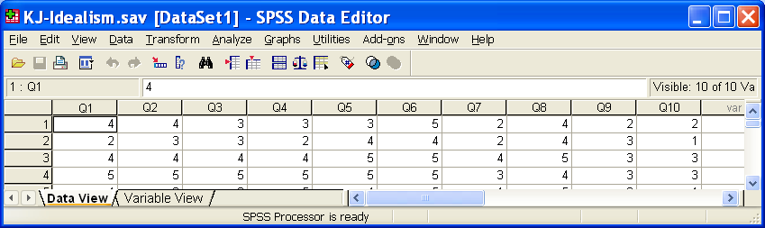

Click Analyze, Scale, Reliability Analysis.

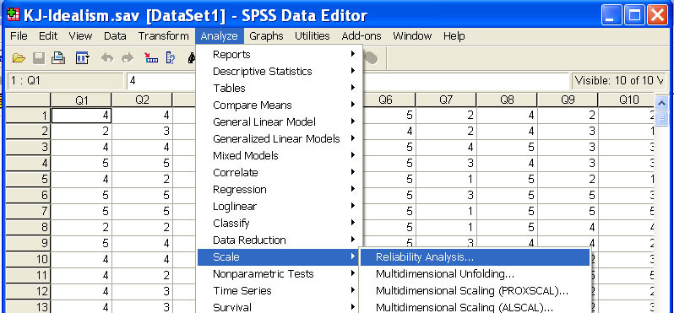

Select all ten items and scoot them to the Items box on the right.

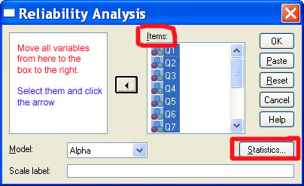

Click the Statistics box.

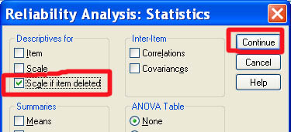

Check “Scale if item deleted” and then click Continue.

Back on the initial window, click OK.

Look at the output. The Cronbach alpha is .744, which is acceptable.



Look at the Item-Total Statistics.



There are two items, numbers 7 and 10, which have rather low item-total correlations, and the alpha would go up if they were deleted, but not much, so I retained them. It is disturbing that item 7 did not perform better, since failure to do ethical cost/benefit analysis is an important part of the concept of ethical idealism. Perhaps the problem is that this item does not make it clear that we are talking about ethical cost/benefit analysis rather than other cost/benefit analysis. For example, a person might think it just fine to do a personal, financial cost/benefit analysis to decide whether to lease a car or buy a car, but immoral to weigh morally good consequences against morally bad consequences when deciding whether it is proper to keep horses for entertainment purposes (riding them). Somehow I need to find the time to do some more work on improving measurement of the ethical cost/benefit component of ethical idealism.

1. People should make certain that their actions never intentionally harm others even to a small degree.

2. Risks to another should never be tolerated, irrespective of how small the risks might be.

3. The existence of potential harm to others is always wrong, irrespective of the benefits to be gained.

4. One should never psychologically or physically harm another person.

5. One should not perform an action which might in any way threaten the dignity and welfare of another individual.

6. If an action could harm an innocent other, then it should not be done.

7. Deciding whether or not to perform an act by balancing the positive consequences of the act against the negative consequences of the act is immoral.

8. The dignity and welfare of people should be the most important concern in any society.

9. It is never necessary to sacrifice the welfare of others.

10. Moral actions are those which closely match ideals of the most "perfect" action.

**Factor Analysis.** It may also be useful to conduct a factor analysis on the scale data to see if the scale really is unidimensional. Responses to the individual scale items are the variables in such a factor analysis. These variables are generally well correlated with one another. We wish to reduce the (large) number of variables to a smaller number of **factors** that capture most of the variance in the observed variables. Each factor is estimated as being a linear (weighted) combination of the observed variables. We could extract as many factors as there are variables, but generally most of those factors would contribute little, so we try to get just a few factors that capture most of the covariance. Our initial extraction generally includes the restriction that the factors be orthogonal, independent of one another.

Copyright 2012, Karl L. Wuensch - All rights reserved.

[Return to Wuensch’s Statistics Lessons](http://core.ecu.edu/psyc/wuenschk/StatsLessons.htm#pca)

1. © Copyright 2012, Karl L. Wuensch - All rights reserved